Project Invent Team Overhead Journal

*(2021-2022)*

| Name | Text Color |
| --- | --- |
| Aadi Shah | Gray |
| Arham Siddiqui | Red |
| Ashar Siddiqui | Orange |
| Nohami Zerihun | Green |
| Sireesha Dandamudi | Light blue |
| Grace Calfee | Blue |
| Rehaan Karnik | Purple |
| Pranathi Ravipati | Pink |

## **16 September 2021 / Meeting Duration: 90 min**

ATTENDEES

* **Everyone here**

AGENDA

* Create a Project Journal
* Discuss when to meet
* Journal link set up/submission
* Calendar set up
* Community partner suggestions
* “Walk a mile” Empathy Activity

# Work Accomplished

* We can meet on Sunday from 11 am-12 pm
* Created Project Journal for our team
* Journal Link Submitted to Mentor
* “Walk a mile”
  + Everyone was given a disability and a task to complete
  + The point is to empathize with people with disabilities and their struggles.

# NEXT WEEK’S AGENDA

* Discuss Community Partners
* Research different aspects of Multiple Sclerosis for community partners.

## **19 September 2021 / Meeting Duration: 30 min**

ATTENDEES

* All

AGENDA

* Discuss Community Partners
* Research different aspects of Multiple Sclerosis for community partners.

# Work Accomplished

* After researching, we learned that the symptoms of MS/MS fatigue included numbness/tingling (in the face, feet, arms), trouble walking/balance issues, impaired vision (blurriness in vision, trouble seeing colors), weakness, pain/itching, and bowel/bladder issues.
* Since bowel/bladder issues was an internal issue, we chose to try to find a solution to the other physical symptoms
* While researching solutions to Multiple Sclerosis, we discovered an existing solution, Transcutaneous electrical nerve stimulation.
* A possible solution to the symptom of balance/walking issues could be to add sensors to the user’s clothing - These sensors would detect when the user leaned in one direction and would beep/emit a sound to alert the user that they should regain their balance
* After further research, we realized that the TENS solution uses low voltage, which may be dangerous to our community partner. For this reason, we may not continue with this idea.
* Compression can help with swollen or stiff joints. We could use this information to create a compressing device (for hands or knees).
* Prevention of MS includes adequate sun exposure and supplement with vitamin D. This means that we could create a device that encourages or reminds the user to go outside more throughout the day, which can prevent them from getting MS.
* While researching, I learned that if you have a family member who has MS, you are more likely to develop the disease. If our community partner has a family member with MS, we should look into creating a product to help prevent MS.
* You can stop MS from progressing by maintaining a healthy diet, getting restful sleep, and not smoking. We can use this information to build a device to help with sleeping for instance or maintaining a good diet.
* There are many forms of multiple sclerosis, each with different and unique symptoms. The most common is Relapsing-Remitting MS or RRMS. 80 to 90 percent of people with MS typically have this form of it. It occurs when inflammation of the central nervous system or CNS in which symptoms can worsen or more may occur. Relapses can worsen during this or new types can happen. The time in between relapses is called remission. Relapses tend to occur every few years.
* RRMS progresses into Secondary-Progressive MS (SPMS). In this phase, symptoms progress, and disability is increased. Their relapses are more common than RRMS, however typically every case of RRMS progresses into SPMS.
* Another form is Primary-Progressive MS or PPMS. This occurs for about 15% of people with MS. In this type of MS, there is no initial relapse that signals the beginning of the disease; symptoms just build gradually over time.
* The last two forms are very uncommon. Benign MS, in which the symptoms progress very little throughout a lifetime after the initial attack. Malignant MS is marked by the rapid formation of lesions in the brain and spine, causing severe symptoms, disability, and possibly death.

# Notes/Links to sources

* <https://www.mayoclinic.org/diseases-conditions/multiple-sclerosis/symptoms-causes/syc-20350269>
* <https://rarediseases.org/rare-diseases/multiple-sclerosis/>
* <https://mymsaa.org/>
* <https://www.nationalmssociety.org/Treating-MS>
* [Home | National Multiple Sclerosis Society (nationalmssociety.org)](https://www.nationalmssociety.org/)
* [What is Multiple Sclerosis (MS)? | The Johns Hopkins Multiple Sclerosis Center (hopkinsmedicine.org)](https://www.hopkinsmedicine.org/neurology_neurosurgery/centers_clinics/multiple_sclerosis/conditions/)
* <https://www.blog.ohmyarthritis.com/compression-gloves-what-symptoms-do-they-treat/>
* <https://overcomingms.org/recovery-program/prevention-family-members>
* <https://www.webmd.com/multiple-sclerosis/rrms-changes-slow-progression>
* <https://my.clevelandclinic.org/health/treatments/15840-transcutaneous-electrical-nerve-stimulation-tens>
* <https://www.ncbi.nlm.nih.gov/pmc/articles/PMC2819898/>
* <https://jamanetwork.com/journals/jamaneurology/article-abstract/587530>
* <https://www.annualreviews.org/doi/abs/10.1146/annurev.immunol.23.021704.115707>
* <https://www.zeposia.com/multiple-sclerosis/how-to-treat-relapsing-ms/?cid=sem_1213844&utm_source=google&utm_medium=cpc&utm_content=MS%20Symptoms&utm_campaign=MS%20Symptoms%20Basic&utm_term=sitelink>
* [https://www.everydayhealh.com/multiple-sclerosis/guide/t](https://www.everydayhealth.com/multiple-sclerosis/guide/)

# NEXT WEEK’S AGENDA

* Assign team roles

## **30 September 2021 / Meeting Duration: 90 min**

ATTENDEES

* All

AGENDA

* Research on the Hatlen Center
* Assign team roles
* Have some interview/introduction meeting topics in mind

# Work Accomplished

* Assigned Roles to all Team Members
  + Ashar - Video Editor
    - Responsibilities: Receive data captures, pictures, files etc. and use them to build, create, and edit a video
  + Arham - Notetaker
    - Responsibilities: Take notes
  + Aadi - Notetaker
    - Responsibilities: Take notes during meetings
  + Rehaan - Notetaker
    - Responsibilities: Take Notes during meetings
  + Grace - Interviewer
    - Responsibilities:
  + Pranathi - Liaison (Communicator)
    - Responsibilities: Email with community partner
  + Nohami - Data Capturer
    - Responsibilities: Record meetings
  + Sireesha - Business/Marketing/Graphic
    - Responsibilities: Make presentations
* Notes on the Hatlen Center:
  + The Hatlen Center ia residential rehabilitation program
  + Students receive training on how to live with their challenges
  + The majority of the students are 18-25 years old
  + They’ve been open since 1953
  + Work with students who have different disabilities
  + Program usually takes 6 months to a year, but can be longer and shorter
  + Applications are accepted for students throughout the United States.
  + The program uses one-on-one individualized instruction in daily living skills, assistive technology, Braille, orientation, and mobility, finance management and pre-vocational skills.
    - Learn to shop and cook, pay their bills, and travel on public transportation, and use computers for college classes/job searching/time management
  + Lies in San Pablo, CA, within walking distance of public transportation.
  + Training in self-advocacy and self-determination
  + Flexibility to attend school or work part-time while in the program
  + Recreation in the San Francisco Bay Area and beyond
  + For adults 18 and older who want to be more independent
  + Curriculum is tailored to help each student
  + Accomodates 18 students in the program for people who are blind
  + What makes Hatlen Center unique from other programs is the fact that each student resides in their own personal apartment during their stay in the program
    - This provides students with independent living, but staff are available to provide assistance if needed
  + Assisted with finding academic classes, volunteering opportunities, and part-time jobs
  + One-on-one and group classes
    - One-on-one classes are in the student’s apartment
  + Received the Virgil Zickel Award
    - Patricia Maffei and The Hatlen Center, Quick and Easy ECC: The Hatlen Center Guide, 2016
* Interview Notes/ Things to keep in mind:
  + Introduce ourselves
  + Ask for permission to record
  + Ask if they have a certain accommodation
    - Any preferences that would make the interview move smoothly
  + Ask for his permission to record the interview
  + Identify who is talking
  + Focus on the person and not just the disability
    - Look out for body language, tone, and such that might suggest that he is uncomfortable
  + Create small talk
    - School

# NEXT WEEK’S AGENDA

* Present questions to Omar (our community partner)
* Research different factors of blindness and brainstorm potential solutions

## **02 October 2021 / Meeting Duration: 20 min**

ATTENDEES

* All

AGENDA

* Get to know Omar

# Work Accomplished

Meeting Notes:

Likes to listen to music

Likes to go for walks

Is 18 years old

Goes to Hatlen Center

Makes braille art

Lost sight of left eye first, then right eye

Had a hard time adjusting

Created connections with others

He is adapting to his journey of being blind

Lives in an apartment complex (probably from the Hatlen Center)

Has to get used to the layout of the place

Learns a lot at the school

Plays instruments as well

Plays accordion

Not in a band, but plays for hobby

Had to relearn his house

Had to count the stairs when walking

Use his hands to navigate his house

Doesn’t use cane in house

Uses his cane when he goes outside

Used to play with legos

Has a roommate (doesn’t use a cane either), and is getting another one soon

More notes from meeting (aside from Arham):

Lost first eye at 7, then lost second 2-3 years ago at 15.

Process of learning how to maneuver without sight was hard at first but he’s getting a lot more used to it

Joined the Hatlen Center in July for a year

Uses sounds for the accordion, learns music in English and Spanish

Braille

* learned this from a TVI (Teacher of Students with Visual Impairments) at school
* she looked up pictures and copied it onto a graph and used the lines of the graph to match up with dots for braille

Struggles with maneuvering in new areas

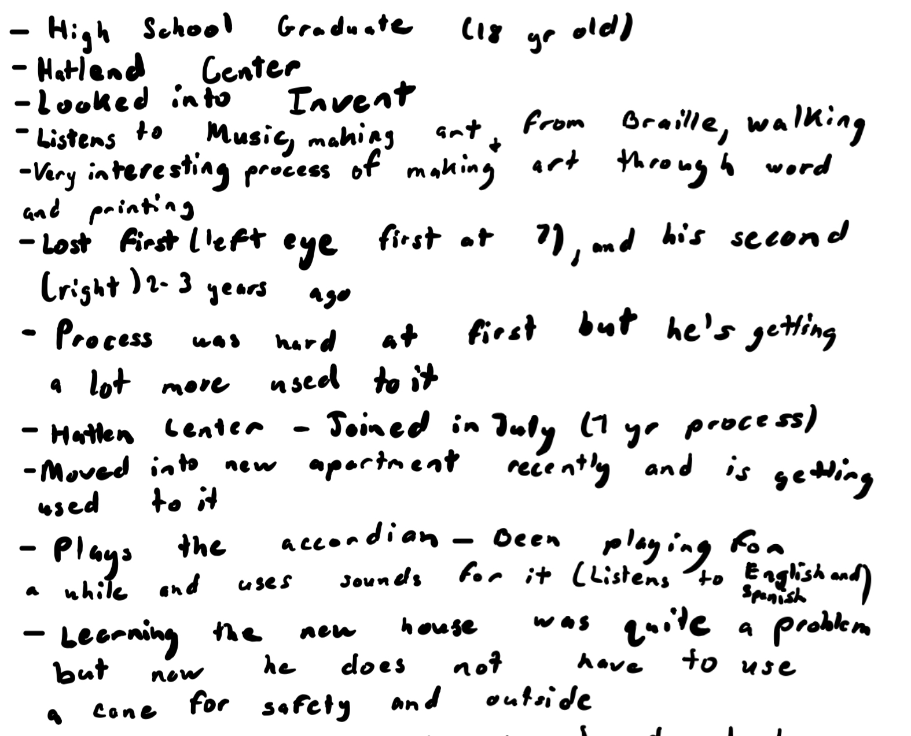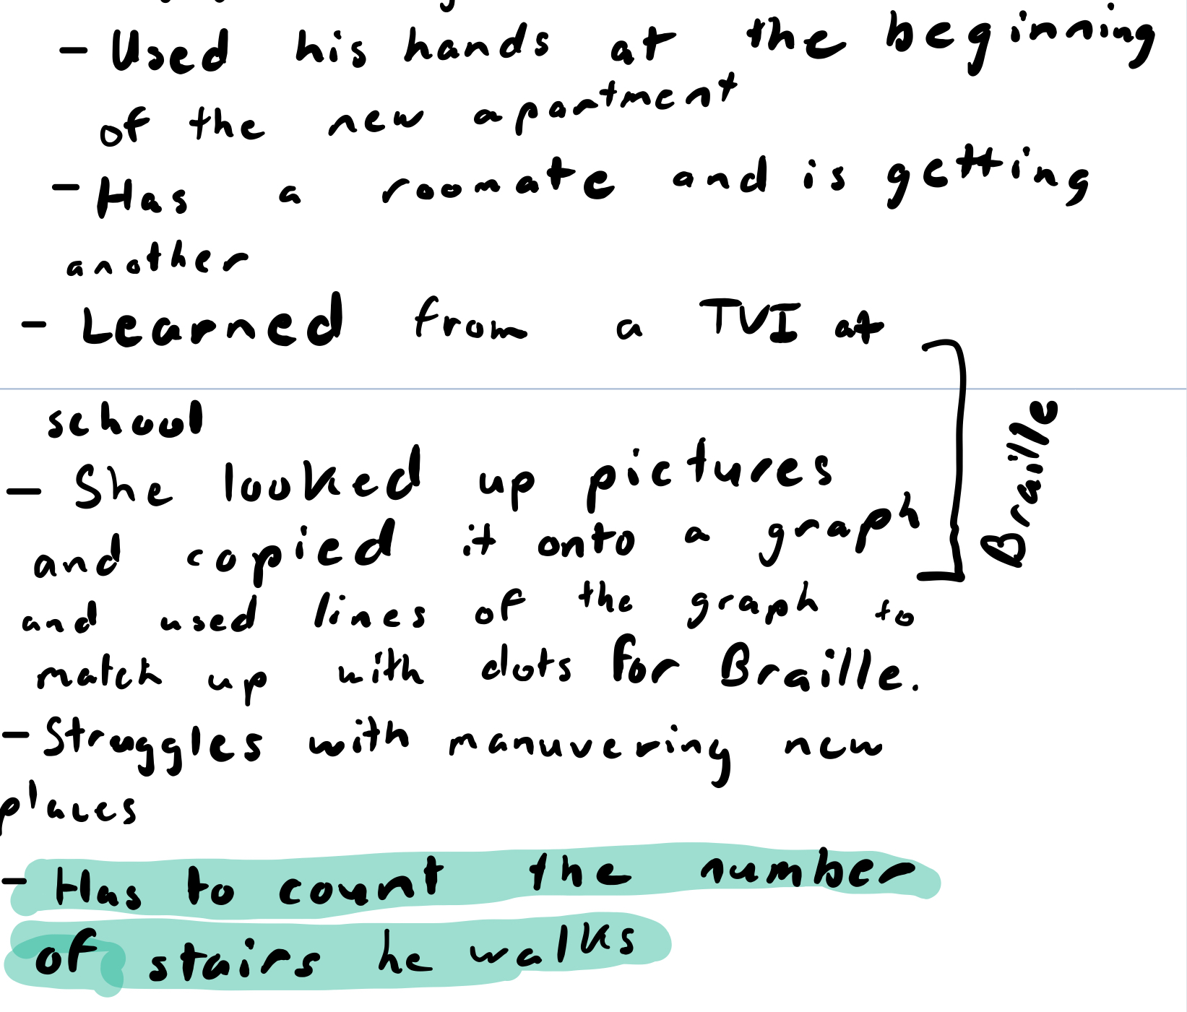

Notes:

* Gets out of the center sometime next year
  + Maybe July
* Listens to and plays music (accordion)
* Makes braille art
  + learned this from a TVI (Teacher of Students with Visual Impairments) at school
  + she looked up a picture, copied it onto a graph, and used the lines of the graph to match up with dots for braille
* Goes for walks

## **07 October 2021 / Meeting Duration: 90 min**

ATTENDEES

* **Sireesha Absent**

AGENDA

* Share the notes that were taken during our meeting with Omar
* Write down some questions that we would like to ask in our next meeting

Work Accomplished

* Finalized and shared notes in journal
* Consolidated notes into one cohesive part
* Thought of questions to ask

Final Notes:

* 18 years old
* Goes to Hatlen Center
* Gets out of the center sometime next year
  + Maybe July
* Listens to and plays music (accordion)
* Makes braille art
  + Learned this from a TVI (Teacher of Students with Visual Impairments) at school
  + She looked up pictures and copied it onto a graph and used the lines of the graph to match up with dots for braille
* Goes for walks
* Has to count the number of stairs he walks in his house
* Doesn’t use his cane unless he is outside, there are people around or he’s in a new place
* Has a roommate who doesn’t use their cane either (getting another roommate soon)
* Lost sight in one eye before the other
* Used to play with legos
* Took some time

Questions to ask in our next meeting (all)

Spokespeople: Main (Grace), Backup (Sireesha)

* Have you been on any fun trips recently? With family or friends?
* Can you give a run-through of your daily life in detail on a weekday? Weekend?
  + Walk us through a day of your life.
  + Maybe some questions arise from his answers…
* What condition caused you to be visually impaired?
* Did you have time to prepare for the full loss of vision? Or was it unexpected?
  + If yes: What methods did you use to help prepare for full loss of vision?
* What is a challenge that you thought would be easy to relearn but was hard? The other way around?
  + Could you walk us through how you learned to do that thing?
* How are you able to use technology (for example in joining the meet)?
  + Follow-up questions: What challenges did you face trying to navigate technology without sight?
* What role does your roommate play in your daily routine?
* What other senses have become heightened since your loss of vision?
* How do you reach items in taller places? Are there any objects you have trouble grabbing or reaching (using)? How does that affect your everyday life?
* Do you cook your own meals?
  + How do you go about operating a stove?
* Could you share one aspect of your daily life that you wish could be improved?

# NEXT WEEK’S AGENDA

* Review notes
* Find more questions

## **14 October 2021 / Meeting Duration: 90 min**

ATTENDEES

**All**

AGENDA

* Omar Daily Map
* Assistive Tech
* Edit Questions

Work Accomplished

* Edited questions
* Mock interview
* Research
* Omar Day Map (Pt. 1)

Next Week's Agenda

* Interview

## **16 October 2021 / Meeting Duration: 90 min**

ATTENDEES

* **Ashar and Nohami absent**

AGENDA

* Share the notes that were taken during our meeting with Omar
* Write down some questions that we would like to ask in our next meeting

Work Accomplished

Notes on today’s meeting with Omar:

* Have you been on any fun trips recently? With family or friends?

When he was a kid, he used to go with his parents to many places. Now that he left living with his parents, he travels with his friends. He goes places to practice moving around independently. He’ll go with friends to nearby locations (liquor stores). When his parents come home on weekends, he travels with them.

* Can you give a run-through of your daily life in detail on a weekday? Weekend? On weekdays, he takes classes. Gets up at 7, makes breakfast for himself, (I think he said chores, what kinds of chores?) changes. His roommate and he clean the apartment. They also do apartment checkups. I Go to classes. Has a lunch break in school. His day ends at around 4pm. The rest of the day he relaxes, does laundry, checks mail, phones his family, makes food (how does he make food?) Enjoys his tech class. Better understanding how to use his phone and computer. (how does he use tech/how did he first start learning to use tech?)
  + Walk us through a day of your life.
  + Maybe some questions arise from his answers…
* What condition caused you to be visually impaired? His left eye went blind due to an incident in school. He recalls having to turn his head around multiple times because he had to see with only one eye.
* Did you have time to prepare for the full loss of vision? Or was it unexpected? He never expected his blindness to happen first.
  + If yes: What methods did you use to help prepare for full loss of vision?
* What is a challenge that you thought would be easy to relearn but was hard? The other way around? Was hard to relearn navigating and learning where everything is, to learn spatial information, and create a mental map of familiar places. Uses walking cane in unfamiliar locations. His house was fairly easy, as he had a good map in his head from before he was blind. Now he can walk into his house/around his house without a cane.

Uses a cane outside the house (did he say he uses his cane in his yard?) No specification, I’d assume no because he said he doesn’t use his cane at home

* + Could you walk us through how you learned to do that thing?
* How are you able to use technology (for example in joining the meet)?
  + Follow-up questions: What challenges did you face trying to navigate technology without sight?
* What role does your roommate play in your daily routine? His roommate is also blind. They talk to each other to know where each is. They hear each other when they enter the house. They can now move around without a cane as they know their way around their apartment.
* What other senses have become heightened since your loss of vision? Says that his hearing has become a lot better. Is with his family and hears noises, all of a sudden someone’s knocking on the door. Is able to hear stuff at a distance. His family members were surprised at his hearing ability. Had started developing it before he lost his sight completely. Lost sense of smell though.
* How do you reach items in taller places? Are there any objects you have trouble grabbing or reaching (using)? How does that affect your everyday life? In the kitchen, everything seems the same, so he has to feel with his hands to get an idea of what he is feeling, what is each piece of equipment in the kitchen. In the kitchen, there is a rack with equipment used for cooking lessons and such. Also remembers what stuff is based on touch. Knives and such, Omar feels the bottom part first (handle) - makes the knife flat on a surface such as a table so he can feel it before he picks it up - same thing with a fork. When he washes dishes, he flips it upside down on the rack, so that the bottom part is placed down so that he can make sure it\ doesn’t touch someone. Uses sighted assistance or uses help from customer service in the stores to read package labels on such. Uses apps on phones to give him information by taking a picture or making a call to someone who has vision to assist him (video call).
* Do you cook your own meals?
  + How do you go about operating a stove? Lost his sense of smell along with sight. Feels how hot it is by putting his hand over the stove. Uses labels on ??? that indicate how hot/high the flame is.
* Could you share one aspect of your daily life that you wish could be improved? If food is expired, he can’t smell so he has to rely on touch or ask someone if it is expired or not.

What kind of chore does he do? Cleaning/picking up dishes after eating, includes washing them, cleaning the kitchen area, taking out the trash, mop, vacuuming, cleaning the bathroom (bathtub, toilet, sink), keeping areas clean so that when they check, it’s tidy.

How did he get back into tech? A friend who was also blind, told him about screen readers and voice-over, things like that - verbal cues. Uses apps to help with this as well.

Can’t see (blindness) and also cannot smell.

Used sense of touch to feel if something isn’t good (for food) or asks someone about it. Does not like financial advisory (bank accounts, paying bills, etc). Starts classes at 9 am and ends at 4 pm. The Hatlen center teaches many real-world financial skills, how to apply for different services. They teach what adults do in real life in the Hatlen Center.

Extra Notes:

(Daily Life) After getting done with his chores after school, in his free time he would make calls with his family, and in his free/extra time he would listen to music, read Braille books, and play music (accordion)

(Condition of Blindness) His unexpected case of blindness required a lot more being aware and having to put more effort in (turning) during the loss of the first eye

(Sharp Tools) Makes sure that aside from the sharp tool (knife/fork) is lying down before using it for safety

Regarding what he did before/after, how he got into Hatlen Center, and what he wants to do, he’d reach out to people such as counselors, the Center, the college, high school, and they would be helping and connecting him to others.

When shopping, he and his friend or roommate will have to go to the front and request customer service. They would come via PA, with a shopping cart, and help maneuver around the store, and show the items they need, the quality, price and expiration date, etc.

hard time to relearn everything, navigate and learn the layout, figure out where things are in each place (mental map), learning to use a cane

can hear better

In the kitchen, everything’s the same, has to feel with hands to know what each thing is, puts items in places in specific orientations so he doesn’t get hurt (knives handle side up)

packages, cannot see labels so uses customer service or use image to speech on phones at home or video call someone with sight

biggest challenge: lost his sense of smell, has to feel food or ask others to know if it’s spoiled or expired

we should ask about his sense of taste next time, as the lack of the sense of smell can affect his sense of taste (we already know that he can't taste spoiled food)

## **23 October 2021 / Meeting Duration: 90 min**

ATTENDEES

* **Grace and Rehaan absent**

AGENDA

* Watch video of the 10/16/21 interview
* Discuss what we can do to improve next interview
* Come up with questions for next interview

Work Accomplished

**Transition Phrases:**

* Ask questions that relate to each other
  + Related to that…
* Restate part of his answer

Next Week’s Agenda

* Start solidifying ideas for Omar
* Start developing more specific questions for our next meeting

## **28 October 2021 / Meeting Duration: 90 min**

ATTENDEES

* **All**

AGENDA

* Synthesize needs for Omar
* Develop questions for next interview
* Decide next meeting time

Work Accomplished

* Developed questions for next meeting with Omar
  + When did you realize you lost your sense of smell, and how did you manage that?

It was hard to manage the lack of smell. He used his sense of taste, hearing, and touch to replace his sense of smell. His taste has not been affected.It was hard at first but he used his sense of taste and hearing to be able to adapt. Now he relies a lot more on his sense of taste. Lost his sense of smell over the next few weeks after losing his sense of smell (15).

* + Do you have difficulty tasting, since you don’t have your sense of smell?

No not really, he has been able to get used to it, and his sense of taste has really taken over and made up for the loss of smell.

* + Clarity maybe about how he detects the temperature of food? At first it was hard, but now he uses touch, taste and hearing to tell if food is hot.
  + Could you explain more about how you can tell if the side of a knife is sharp or if it’s the handle? Depending on the knife, he feels the handle. (how does he know which side?) Uses the shape of the handle and the feel of it, to make sure it is the right way. How are you able to find something that you may have lost? First, he tries to feel around carefully. If that doesn’t work, he would ask someone around him to find it. He has some apps on his phone that can connect to video and others can help him find the item without it damaging him.
  + How are you able to differentiate a roommate from an intruder? Uses recognition of voice, and his hearing is good enough to understand.

Also asks “Who is it?” and uses their name and their response to see who it is, also using the voice of them to navigate that.

* + Do you have any trouble reaching things in higher places around the house? For example, are there things on high shelves that can be difficult to find or reach? Not really, he is tall and has long arms. He can easily reach items on high shelves.
  + Do you have any specific challenges when walking in unfamiliar places? Trouble when trying to figure out his orientation. However, his cane helps with this problem. Uses his phone (google maps) to know where he is.
  + Are there any specific challenges that you encounter in your daily life that we haven’t mentioned before? Branches, signs and other obstacles that are above eye or head level that the cane will not detect, because the cane can only go on the ground.
* Established meeting time with Omar
  + 6:30 pm on October 30, 2021

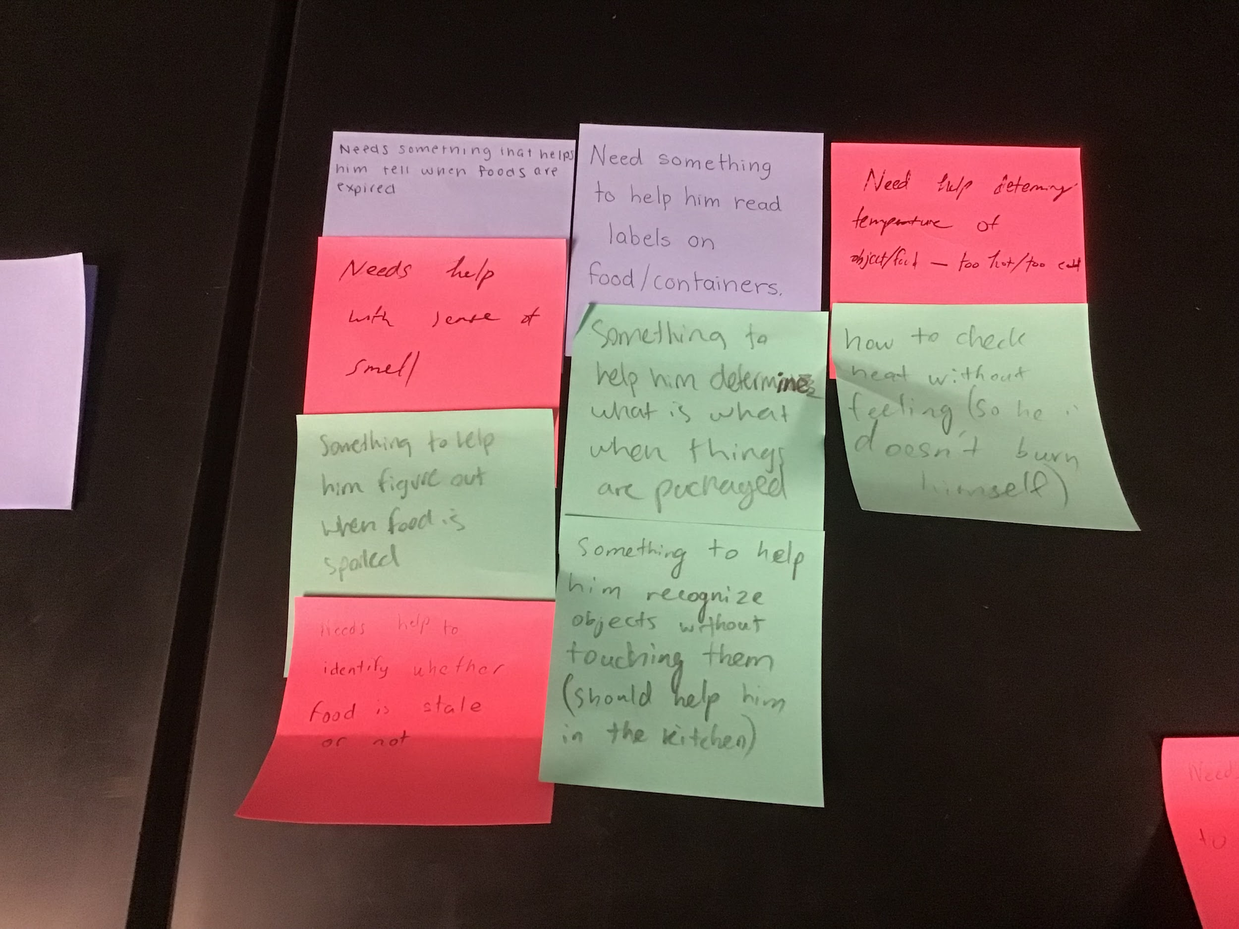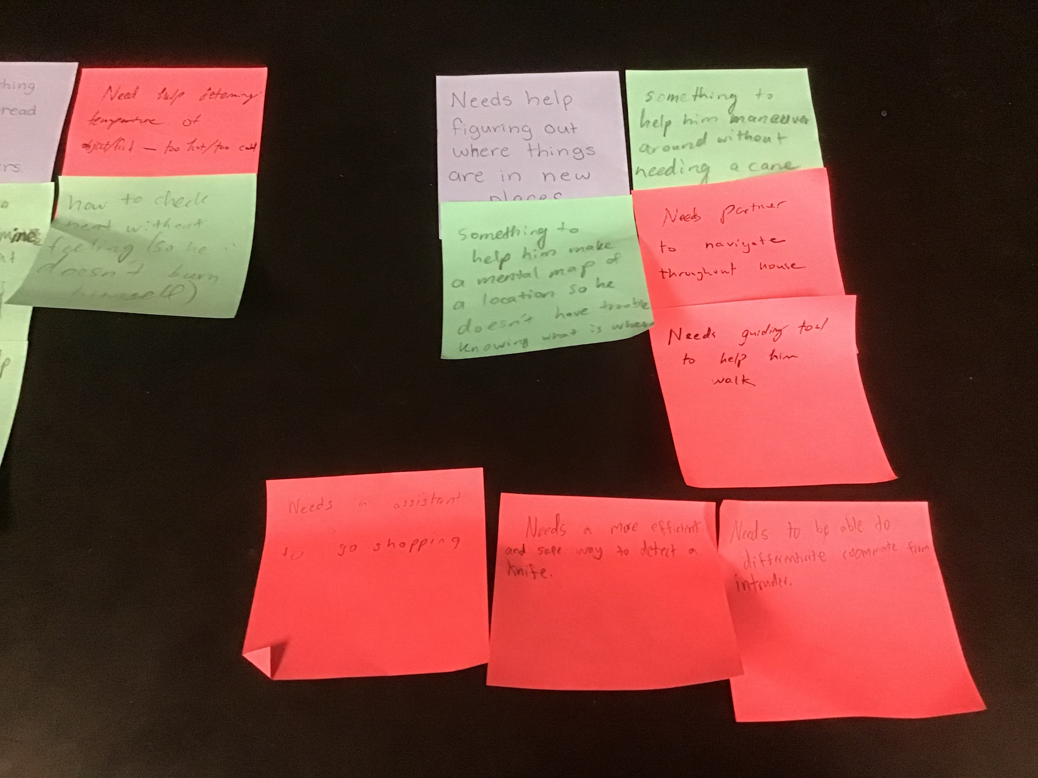

Next Week’s Agenda

* Meeting with Omar

## **30 October 2021 / Meeting Duration: 90 min**

ATTENDEES

All

AGENDA

Meeting with Omar

SHORTLIST

Food Spoiling

Walking and Obstacles above cane level

Would like to improve

Play and listen to music

Tactile Art

Lost his smell after a few weeks of losing his sense of sight.

Next Week’s Agenda

* Consolidate the information to find needs/problems
* Come up with questions to ask based on meeting

## **04 November 2021 / Meeting Duration: 90 min**

ATTENDEES

All

AGENDA

* “How might We?”
* Look over video and find quotes
* Email Omar for clarifying questions
* Discuss when we will meet to make up hours

WORK ACCOMPLISHED

“How Might We” Statements:

**How might we... help Omar detect overhead objects that his cane can’t identify in order to help him avoid head injuries or other safety issues.**

**Quote: “Have to know when I’m walking, obviously you guys know there are branches sticking out of trees, signs above eye level, that obviously my cane is not going to feel, because the cane is on the ground. Sometimes we use our hand, but we might know that something is there, so that is something else we sometimes have to deal with mostly, throughout when I go walking on the street or things I may not know where there about head level, that I can’t feel with the cane because it was *obviously* on the ground because the cane is on the ground so that’s another issue I have to deal with.”**

**How might we... help Omar differentiate when a food item is extremely hot or cold in order to avoid burns and other extreme temperature-related injuries.**

**Quote: “Yea, a little now, yeah. First it was hard but now I’m able to kind of like mostly feel the temperature, like with the foods and everything. Kind of feel or sometimes hear, like if there is smoke in the food, or like it’s hot I’m able to hear a little. And feel as well at the same time instead of being able to smell as much as I would. I use my other senses to do stuff.”**

**How might we… aid Omar and his challenges to identify spoiled foods in order to prevent future health risks.**

**Quote: Not exact, lost recording**

Email to Omar:

* Send the problems we have to Omar, so that we can clarify that these are all things that he wants to be solved
* Is there any technology or solutions for specific problems that you would like to be improved?
* Re-ask about his troubles with spoiled food.

Next Meeting’s Agenda

* Team meeting
* Send email to Omar

## **06 November 2021 / Meeting Duration: 75 min**

ATTENDEES

Grace absent

AGENDA

* Notes
* Questions
* Brainstorming

WORK DONE

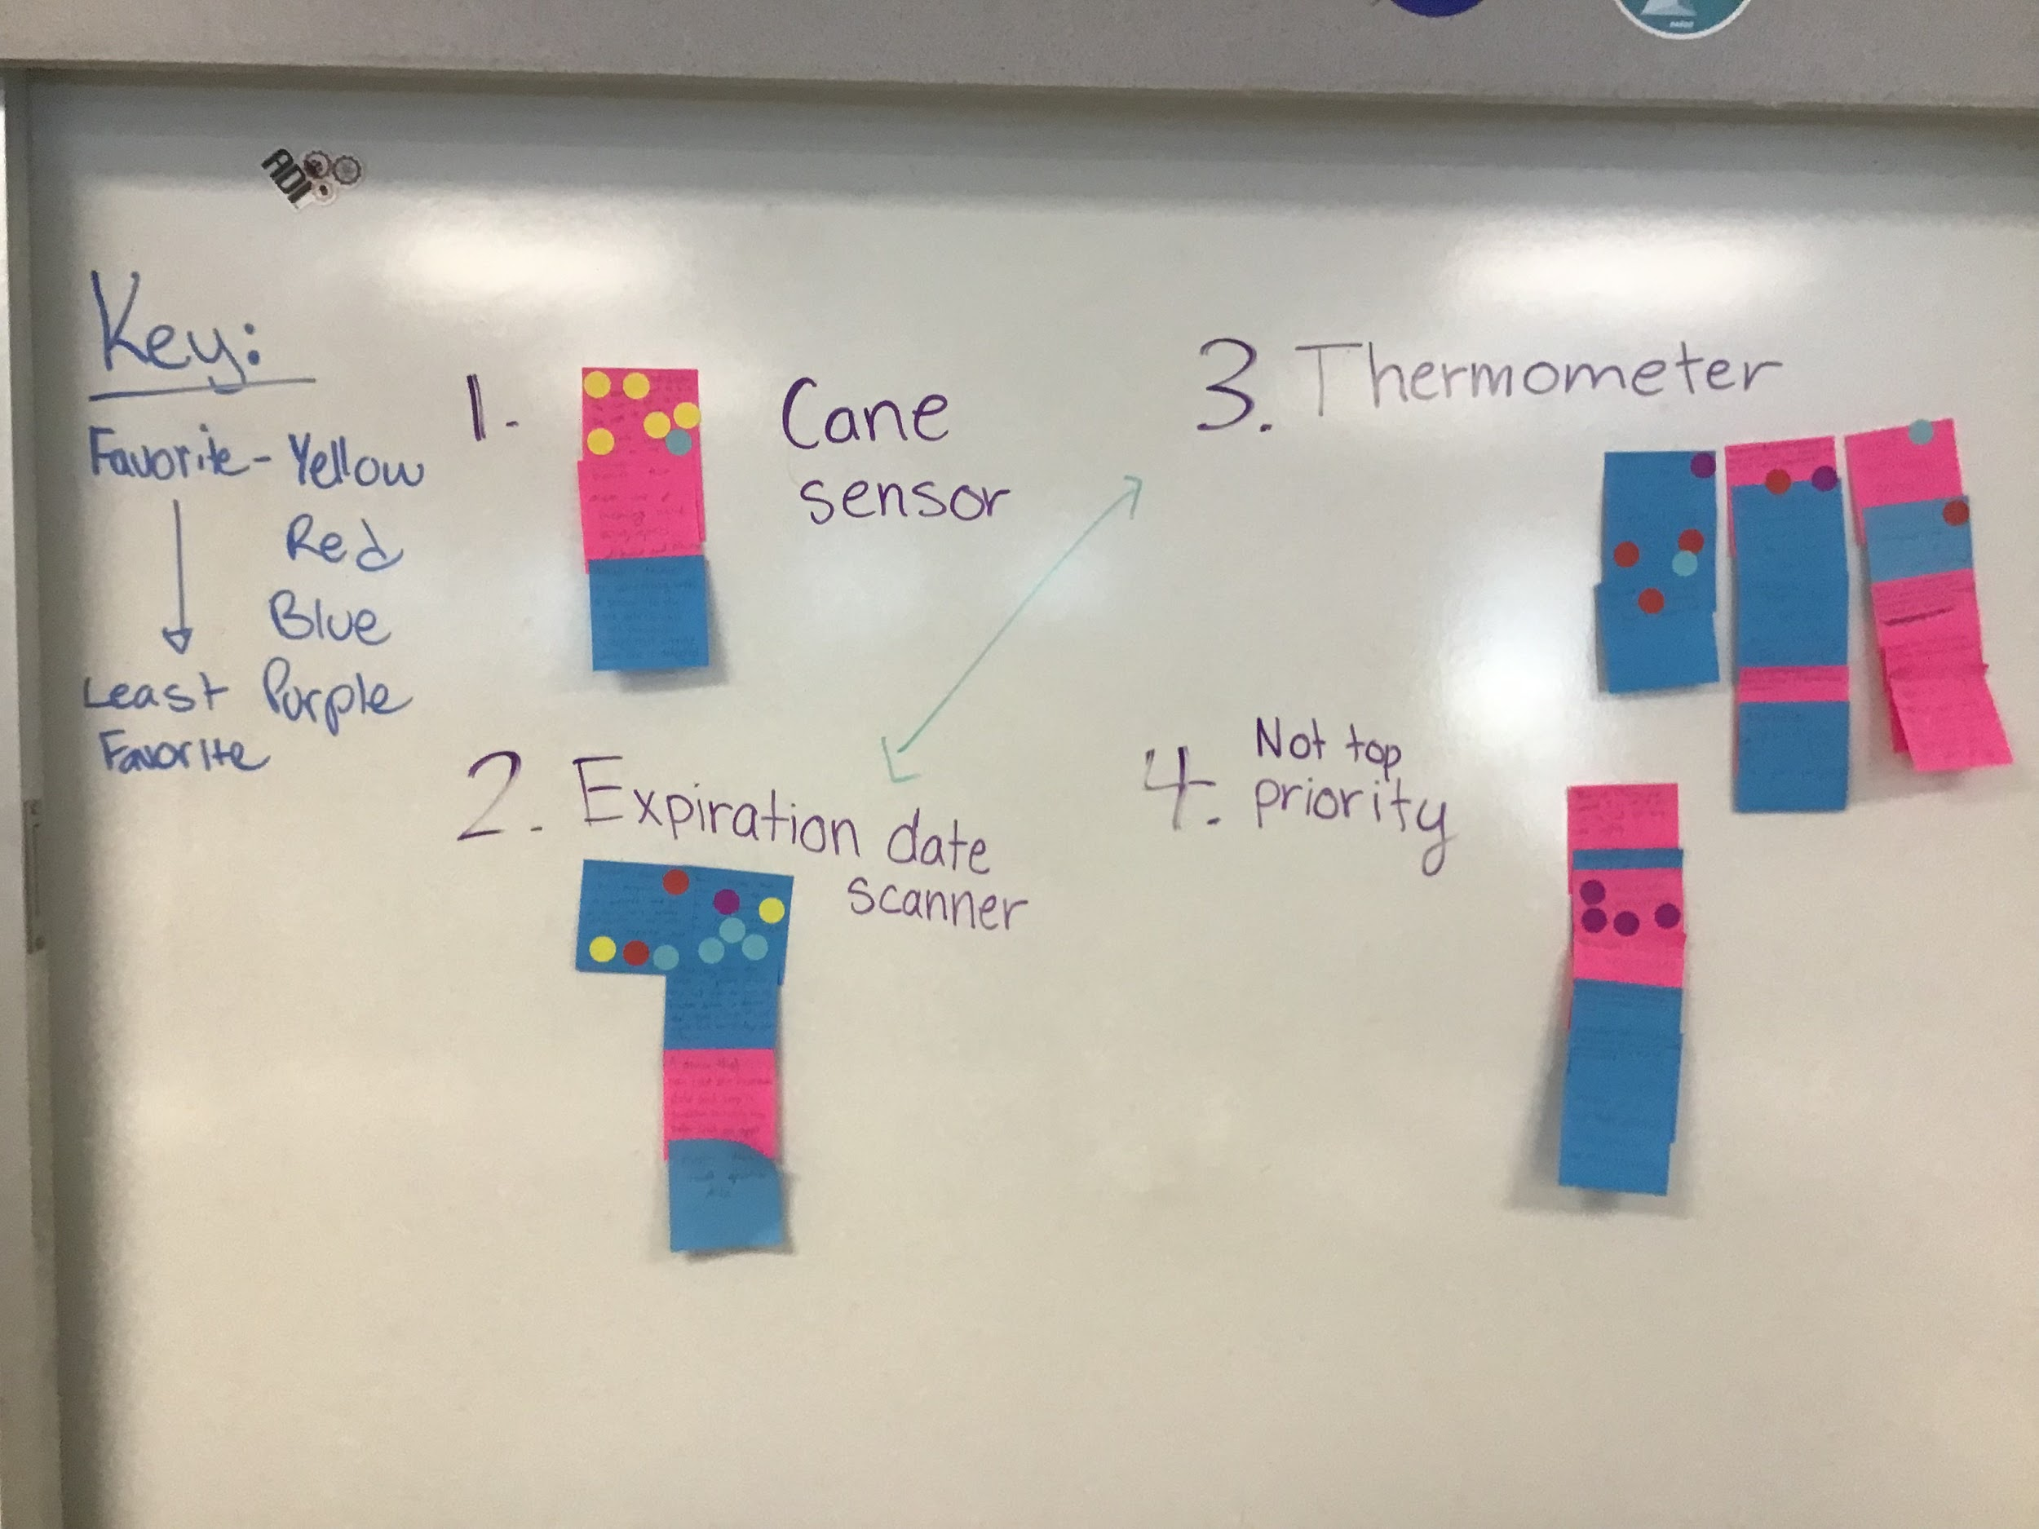

NEXT MEETING

* Work on email
* Discuss the possible solutions

## **07 November 2021 / Meeting Duration: 60 min**

ATTENDEES

All

AGENDA

* Work on email
* Discuss the possible solutions
  + Pro and Cons
* Brainstorming

WORK DONE

* Shortlist
  + Cane sensor:
    - Pros
      * Solves one of his main problems which is bumping into branches on his daily walks
      * Simpler design, not to complicated
      * Already adds to something he uses, not anything new
    - Cons
      * Similar idea done before (although Ms. Spector did say it was not the same)
      * May take a little more work
  + Expiration Date Scanner
    - Pros
      * Again helps with a problem identified for him
      * Makes sure his food doesn’t get spoiled and he doesn't eat unhealthy food
    - Cons
      * Definitely the hardest to design
      * May not be anything that someone can't help him with, and there’s probably already a feature for that
  + Thermometer
    - Pros
      * Since it is a smaller device, it may be easier to work with and prototype.
      * Helps to solve a problem.
    - Cons
      * There could be trouble in communicating thermometer data to the alert system.
      * Our community partner might not find this as a large problem
      * Our community partner might not find this product more efficient than his own hands.
  + Accessories scanner
    - Pros
      * The sensor can travel with him
      * It would be hidden in a common accessory, not to attention-grabbing
    - Cons
      * Daily tasks could harm the accessories
        + Ex. Accessory is a ring and the community partner is washing his hands

Could ruin the sensor’s circuitry

NEXT MEETING

* Do research on existing solutions for the one solution that Omar picks out
* Start planning out the details of the final solution/problem

## **09 November 2021 / Meeting Duration: 90 min**

ATTENDEES

All

AGENDA

* Answer Sanity questions
* Draft another email to address problems (i.e. feasibility of cane)

WORK DONE

Sanity Check:

**Idea #1: Cane Sensor**

Has this idea been done before?

Yes, this idea has been done before. Website: <https://wewalk.io/en/>. But it is not the same and we can use things like cameras and text to speech (WeWalk has a voice assistant) instead of a vibrating system. Also, a similar project with the same problem has been done before (on a dog harness) IN PROJECT INVENT.

Does our idea stand out from existing products on the market?

It does not stand out, as it is similar to existing products from Project Invent and outside sources (ex: WeWalk: smart cane for the visually impaired). But it is possible to add additional features that other products do not provide, catered to our partner’s needs.

Will people actually buy/use it?

People will probably buy/use it since it solves a major problem, and has many uses built into the product.

Can we build it?

Yes, but it has already been built. (An extremely similar thing)

Are we excited about the idea?

We are excited about the idea, as it will help our community partner with a major problem he encounters. However, the fact that this idea exists already may present challenges in our design process.

**Idea #2: Thermometer**

Has this idea been done before?

Similar to the cane, there are some models that are similar to ours, but they are not the exact same. While a thermometer that both vibrates and produces audio feedback regarding temperature does not exist, a “talking” thermometer has been created in order to aid senior citizens and visually impaired people.

Does our idea stand out from existing products on the market?

This product stands out from existing products because it uses vibration instead of auditory response. This is more efficient and less disturbing to others around the visually impaired user.

Will people actually buy/use it?

People with visual impairment would buy our product because it solves a problem of theirs efficiently and without the need of auditory feedback (vibrates instead of talking to them).

Can we build it?

Yes.

Are we excited about the idea?

For the majority, yes.

**Idea #3: Expiration Date Scanner**

Has this idea been done before?

Yes, this idea has been done before but there is nothing on the market, just concepts and prototypes.

Does your idea stand out from existing products on the market?

There is not a similar device on the market as of right now, so it would definitely stand out. (https://www.beepscan.com/en)

Will people actually buy/use it?

I would assume, since it would aid those who can’t identify the expiration dates on food.

Can we build it?

It might be slightly challenging to build, considering it hasn’t really been done before, but I think we could probably get at least a pretty good semi working prototype in the time we have. Also, each member in our group brings a different skill to the table which we can use to fabricate our prototype. However, designing and constructing the appropriate algorithm may take some time, as making it accurate and efficient will need a lot of data.

Are we excited about the idea?

Yes, as it would help the blind community with a problem they face in their daily lives.

Yes, we are excited about the idea because it would help someone’s life become even the slightest bit easier.

NEXT MEETING

* Finish slideshow
* Discuss ideas for video
* Send email to omar

## **20 November 2021 / Meeting Duration: 240 min (STEM Saturday)**

ATTENDEES

All

AGENDA

* Finish slides
* Film all parts of the video
* Consolidate all parts of the video and turn it in

WORK DONE

* Filmed all parts of the video
* Finished the slides & agreed on a top idea (hat sensor)
* Currently editing the filmed parts of the video

NEXT MEETING

* Look at feedback for the video
* Consolidate idea for hat sensor (what different elements are we going to include)
* Ask omar about the name for product and specific problems he has while walking

## **30 November 2021 / Meeting Duration: 90 min**

ATTENDEES

All

AGENDA

* Review Idea Review Video feedback as a group
* Fix and edit some parts
* Finish final Idea Review Video

WORK DONE

* Filmed all parts of the video
* Finished the slides & agreed on a top idea (hat sensor)
* Currently editing the filmed parts of the video

NEXT MEETING

* Review Feedback from Final Idea Review

## **04 December 2021 / Meeting Duration: 90 min**

ATTENDEES

All

AGENDA

* Create follow up questions
* Consider feedback from experts
* Assign roles for the idea review event

WORK DONE

Answers to Feedback Questions:

Q: How much does it weigh?

* Maximum weight of 50 g.

Q: Does it mount on various hats and caps?

* We are thinking of creating a prototype that can be mainly mounted on hats and caps using a clip-on feature. This would allow the device to be clipped onto hats and caps with different styled brims and shapes.

Q: Will it work for women?

* Technically, it should not have to be any different for Omar, or another person whether they are a man or woman.

Will it work for men/women with various hair styles?

* Undecided on how we will adjust to that
* If we do make the device detachable, then we will be able to adjust for the different possible hair styles, etc. If this product was being sold I think there would be multiple styles of hats that this would be sold with, so the user could choose based on what best works for them.

Can it be used without a cap/hat? Perhaps with an arch? Or worn on the chest or as a necklace?

* So far, our prototyping ideas have been only for hats. We believe that a clip-on device to a hat would be the most effective, but are open to other ideas. If the device is to be attached to a necklace, wires connecting to the device would ruin the aesthetic of the necklace, causing it to look weird. In addition, the weight of the device might cause the user to not want to wear the necklace, defeating the purpose of it.

How will it be powered? How long will that last?

* Multiple ideas for this
  + Option 1: Solar Powered with Storage Unit
  + Option 2: Normal covered battery pack
  + Bluetooth Powered

Where will the speaker be? Will it be audible and loud enough? How often will announcements repeat?

* Somewhere integrated with the device/clip-on
* Will be louder the closer you get to it
* It will repeat with a _ second wait

Roles for the Idea Review Event:

* Greeter: Pranathi
* Questioner: Sireesha
* Fielder: Rehaan

Follow Up Questions:

1. We have been thinking about the fact that it should be able to adjust to different people and their unique hairstyles. Do you suggest we make it a small, portable, clip-on that we can add to accessories such as caps and necklaces? If so, how should we go about doing that? Or should we make an accessory that is adjustable, such as a cap that is comfortable for all people, no matter what their hairstyle is?
2. We noticed you said that we should focus on one scenario and then expand from that point on. Where do we stop in terms of how many scenarios to keep in mind? Could you elaborate on this idea?
3. Considering that the objects that we are focusing on are tree branches and street signs, is there any way to focus on both range detection and obstacle detection? Could we use multiple ultrasonic sensors with their beams set to different ranges to do both?
4. How might multiple ultrasonic sensors be used to eliminate the blind spot that occurs in front of an individual ultrasonic sensor? Do you recommend any resources that could help us learn more about this?
5. Do you know what the best hardware would be to run this type of device considering size restrictions etc.?

NEXT MEETING

Simulation of Breakout Room

## **09 December 2021 / Meeting Duration: 90 min**

ATTENDEES

All

AGENDA

* Do a practice run-through of the Idea Review Event

WORK DONE

* Did a practice run-through of the idea review event
* **Phrases to use if you’re unsure of an answer:**
  + I’d love to do some more research before I get you an answer.
  + Here’s what I do know and here’s how I’ll get you an answer.
    - Don’t say this exact thing, it’s just a format

NEXT MEETING

* If time, edit some of the feedback questions
* Attend idea review event on 12/11/21, this Saturday

## **11 December 2021 / Meeting Duration: 90 min**

ATTENDEES

All

AGENDA

* **IDEA REVIEW**

WORK DONE

Answers to Follow Up Questions

Basic Product Description: Our product is essentially a cap with an ultrasonic sensor, text to speech feature, and other elements that will detect overhead objects above the waist level

1. We have been thinking about the fact that it should be able to adjust to different people and their unique hairstyles. Do you suggest we make it a small, portable, clip-on that we can add to accessories such as caps and necklaces? If so, how should we go about doing that? Should we make an accessory that is adjustable, such as a cap that is comfortable for all people, no matter what their hairstyle is?

* V:
  + Simplify it
  + Don't make it something that is too complicated
  + Stick to the core of our idea for our CP, and then make it better after
* B:
  + Decide what we want, pick what he want for now and then see what comes up
* “What if I wanted to wear something different today?” They might want to wear something else that day.

1. In the feedback you gave us, we noticed you said that we should focus on one scenario and then expand from that point on. Where do we stop in terms of how many scenarios to keep in mind? Could you elaborate on this idea?

B:

* + Elaborate for which scenario we are focusing on.
  + Work really well on one thing, and then introduce a complexity later

1. Considering that the objects that we are focusing on are tree branches and street signs, is there any way to focus on both range detection and obstacle detection? Could we use multiple ultrasonic sensors with their beams set to different ranges to do both?
2. How might multiple ultrasonic sensors be used to eliminate the blind spot that occurs in front of an individual ultrasonic sensor? Do you recommend any resources that could help us learn more about this?
3. Do you know what the best hardware would be to run this type of device considering size restrictions etc.?

NEXT MEETING

* NOTES:
* Focus on the core features, that we want to put in our core product
* If form factor is essential, then think about it
* If it isn't, then it almost doesn't matter
* Pick one of those, then move on because there will be a lot more challenges along the way
* After finishing the other challenges, come back to this and then make a decision
* Focus on a few MAIN scenarios. Get ONE situation to work VERY well.
* After this, introduce another complexity, and grow from there.
* I basically have this written down in the questions

## **06 January 2022 / Meeting Duration: 90 min**

ATTENDEES

Sireesha and Rehaan absent

AGENDA

* Discuss feedback received from mentors from IDEA REVIEW
* Start planning our prototype
* Make a list of materials we will use

Work Done

* Materials Needed:
  + Hat <https://www.amazon.com/Falari-Snapback-Style-Adjustable-G201-01-Black/dp/B07FMBY7G4/ref=sxin_14_ac_d_mf_rf?ac_md=1-0-QmxhY2s%3D-ac_d_mf_rf_rf&cv_ct_cx=Flat+Brim+Hats&keywords=Flat+Brim+Hats&pd_rd_i=B07FMBY7G4&pd_rd_r=c08ed696-b7f3-4672-a9bb-66fae55c5e4e&pd_rd_w=WkdEW&pd_rd_wg=xuzj6&pf_rd_p=a096e525-a495-453a-86b7-b8874baad0af&pf_rd_r=WZX1PVC2WD013ATQ27XK&psc=1&qid=1641483923&sr=1-1-1db1fce3-1628-43df-a6c6-84620ba4aaaa>
  + Arduino
    - <https://mellbell.cc/products/pico>
  + Battery pack
  + Ultrasonic sensors
    - <https://www.amazon.com/diymore-Waterproof-Ultrasonic-Measuring-Transducer/dp/B01J5KZU8M> (waterproof)
  + Breadboards
  + Glue (To mount sensors onto the hat)
  + Wiring (Resistors, etc)
  + Waterproof material/small container
  + Speaker
* Roles for Creating Prototype:
  + Hardware & Software (Ashar, Arham, Aadi, Rehaan, Grace)

NEXT MEETING

* Search up specific materials and costs
  + Fill this out: <https://docs.google.com/spreadsheets/d/11qHp0mGWtZnxnHDT_hjekKaI2BOsRj7TryrvLBdxoZg/edit?usp=sharing>
* Find a reasonable budget for prototyping + final project
* Meet Omar (possibly on Saturday or Sunday)

## 

## **08 January 2022 / Meeting Duration: 90 min**

ATTENDEES

Sireesha, Grace, and Nohami absent

AGENDA

* Finish CAD simulation of Arduino

Work Done

* We chose to use two ultrasonic sensors to show which side of the user the object is on.
* We chose to use vibrations instead of a text-to-speech feature. Vibrations will be more comfortable for the user in general. They will be able to speak to others while walking, while with the other feature, they would not be able to concentrate on their conversation if they encounter an overhead object. It would be more comfortable to not have to hear a voice while they are walking. Omar also liked the vibration idea for our original idea with the cane.
* CAD simulation
  + There will be two ultrasonic sensors, one on either side of the hat, on the outside of the hat. The two vibration motors will be on the inside of the hat.

Vibration Motor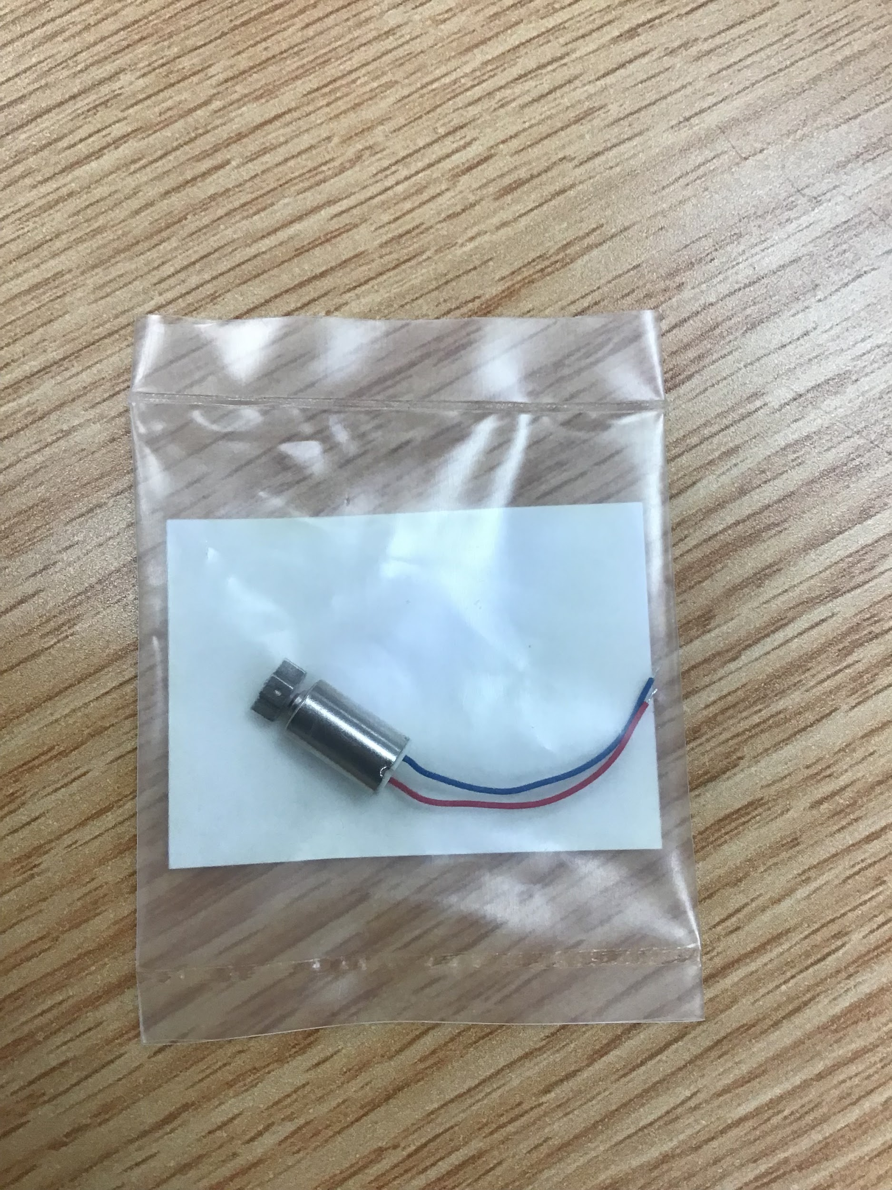

* + - Vibrates on the left if there is an object on the left side
    - Vibrates on the right if there is an object on the right side
    - The user will have to duck a little in every situation.
  + Starts vibrating from 210 centimeters (11 feet) away from the object
  + Vibrates faster from 150 centimeters (5 feet) away from the object to show that the user is getting closer to the object
* Would we use the Arduino Uno or the smaller Arduino?
* If we use the bigger one, where would we put it?
  + Maybe the back of the hat

NEXT MEETING

* Build prototype based on CAD

## **13 January 2022 / Meeting Duration: 90 min**

ATTENDEES

Sireesha absent

AGENDA

* Create physical prototype based on CAD

Work Done

* We checked out an Arduino kit (overnight, will be going home with Rehaan)
* We managed to use an Arduino kit to make an LED light up. At that point, we added a vibration motor, and once we get a distance sensor, we will use the program we have created to create a very basic prototype of our project.
* We created a physical prototype of the hat with cardboard
* We finished the stage 1 code 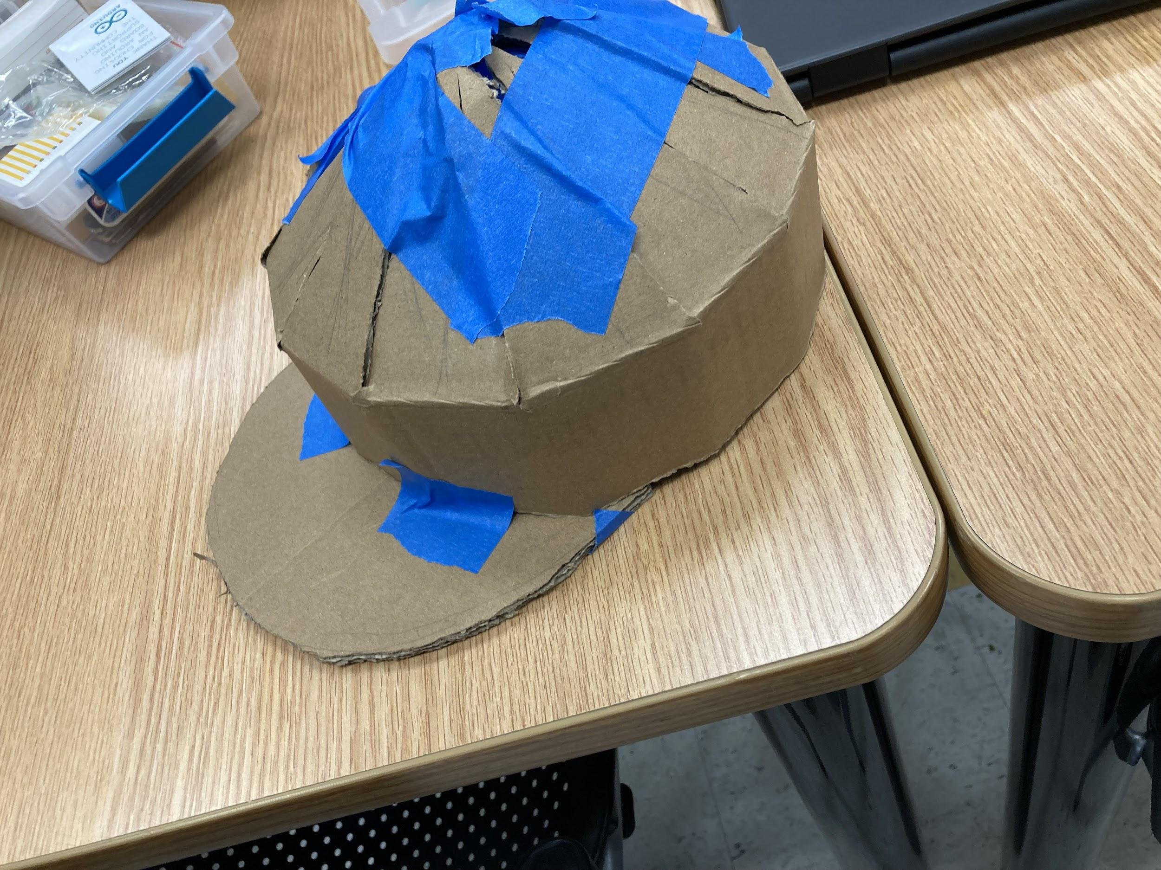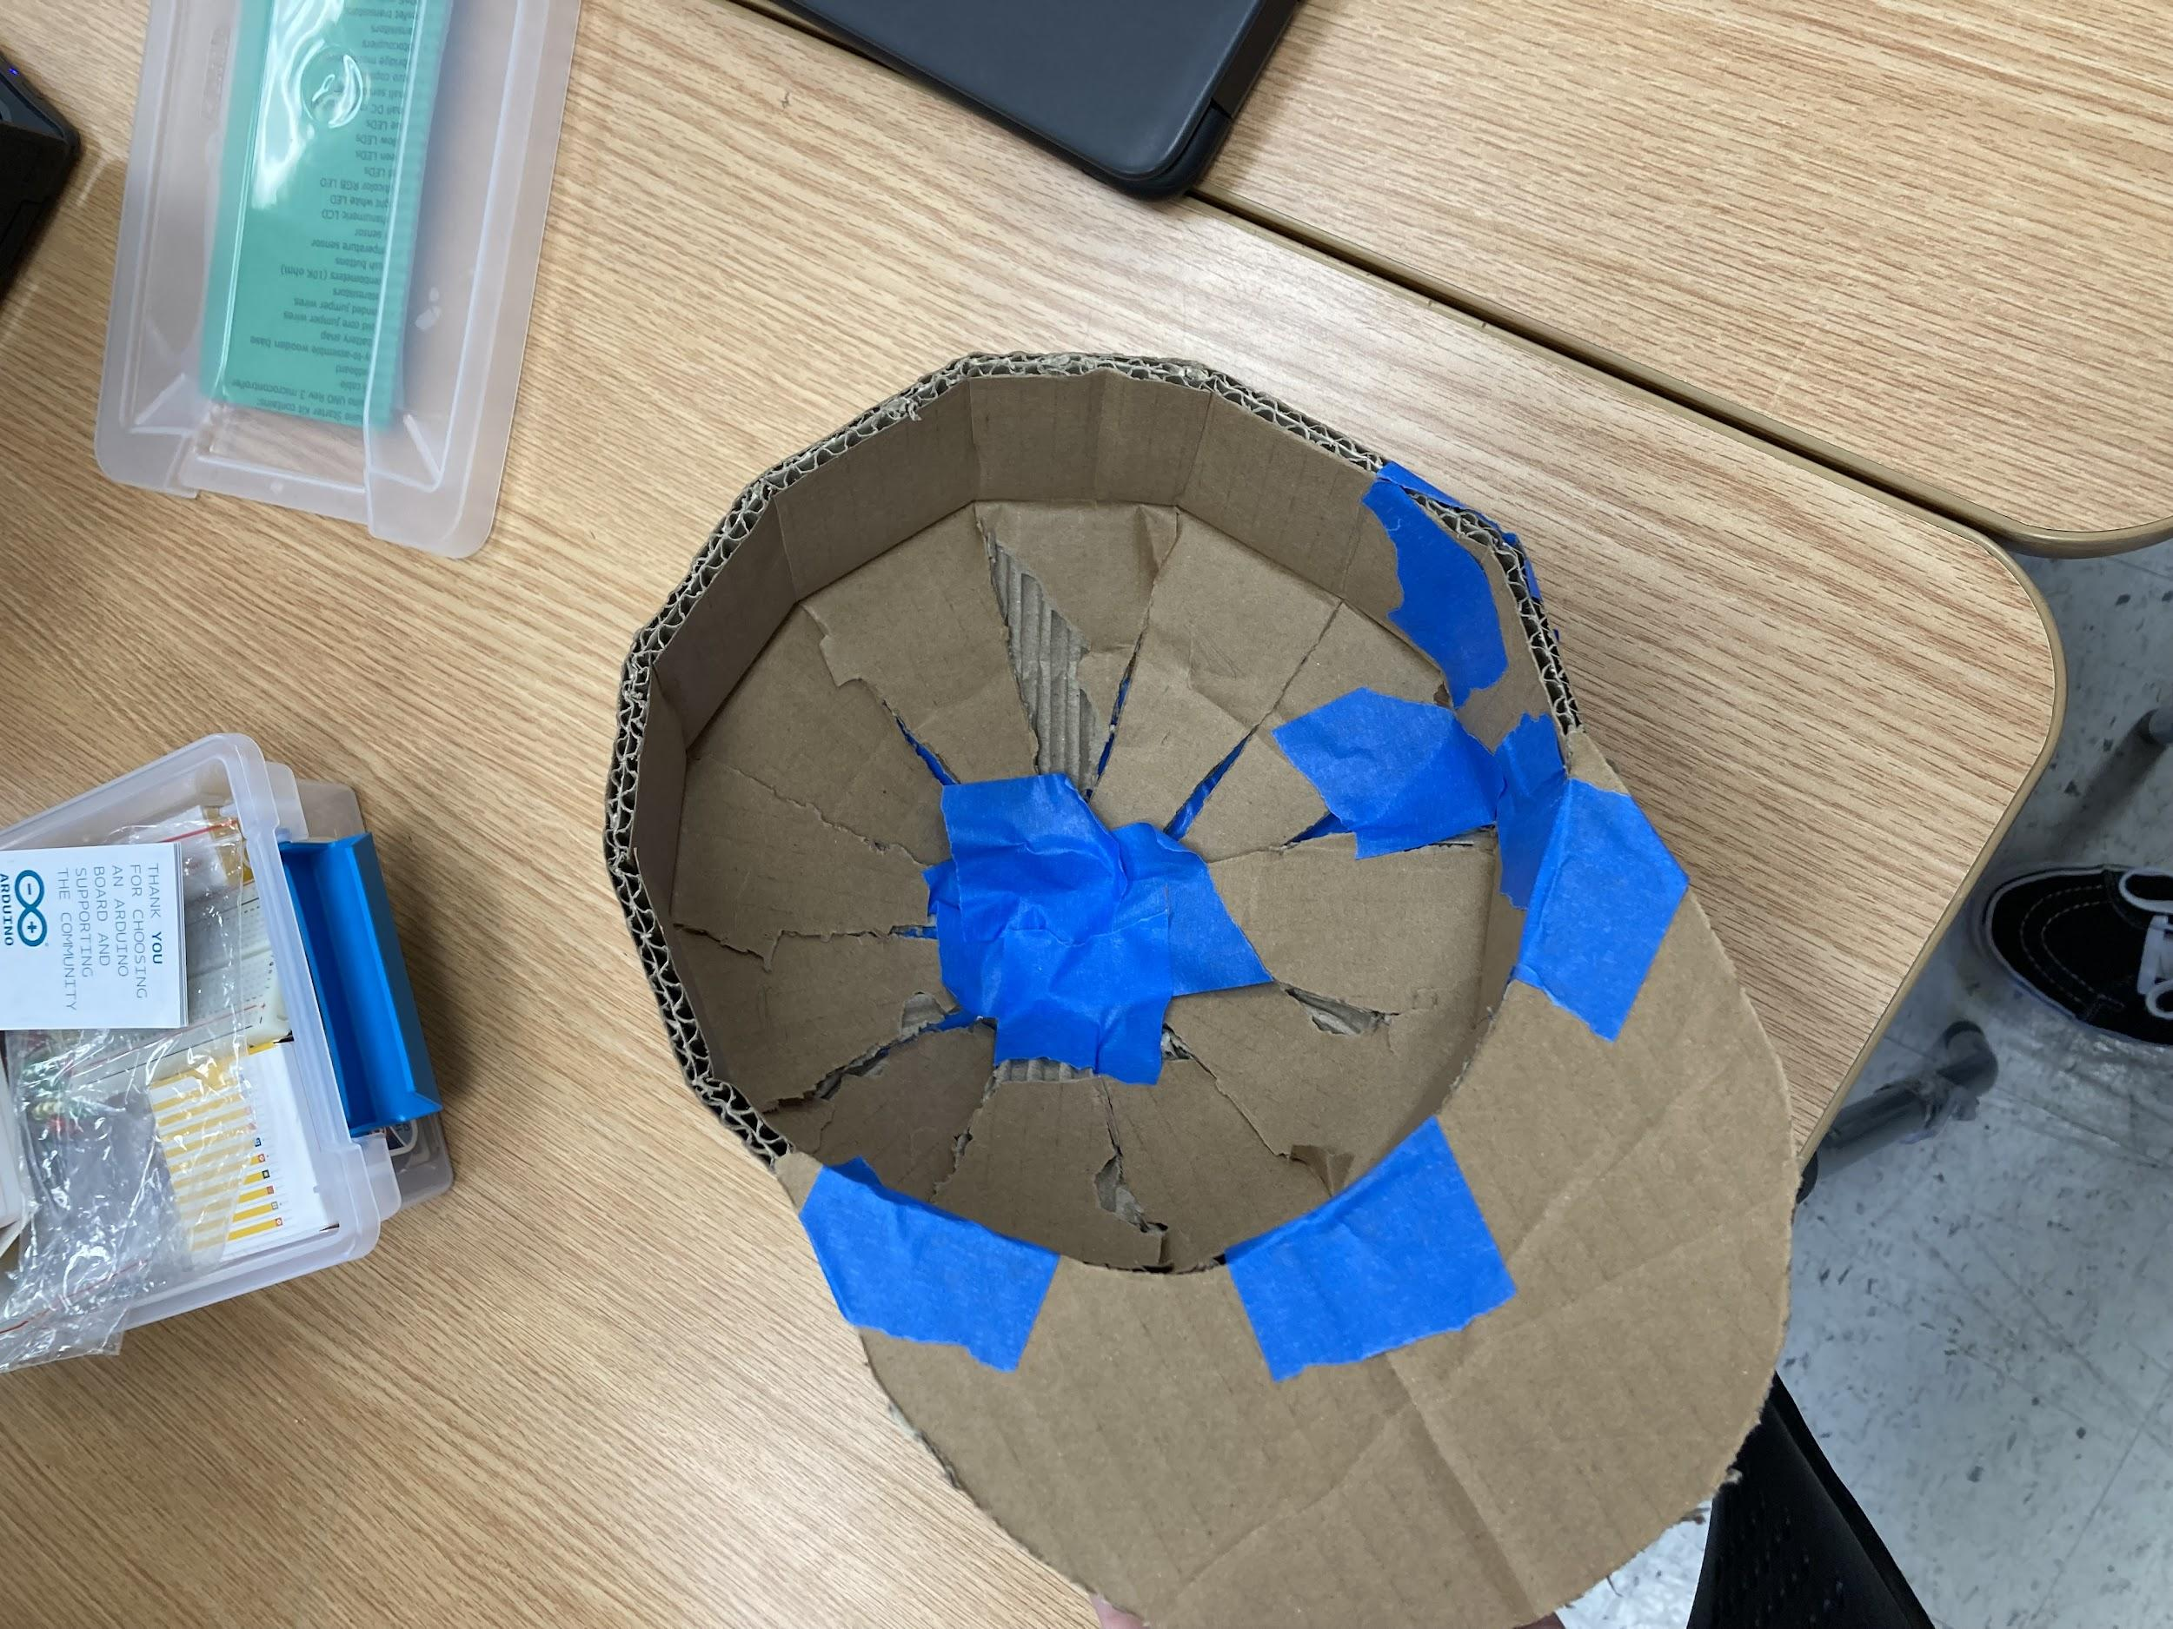

NEXT MEETING

* Build prototype based on CAD
* Add where the sensors will be onto the cardboard hat

## 

## 

## 

## **20 January 2022 / Meeting Duration: 90 min**

ATTENDEES

All

AGENDA

* Pick official team name
* Choose demo day date
* Work on prototype

Work Done

* Team Name: Team Overhead
* Saturday meeting with Omar
  + Tell him about our new model (Switch from cane to hat)
  + Tell him about how wearing a cap would be advantageous as opposed to attaching our product to a cane
    - Sensors on the cap would be at head level (could more accurately/easily detect the overhead objects)
  + Ask him for opinions about product
* What we want to put on the Demo Day slides
  + Introduce community partner
  + Introduce idea
  + How we came up with the idea (mention how Omar likes this idea the best)
* Tried to find battery case
* Worked on Arduino setup
  + Got ultrasonic sensor
* Finished code
  + Trying to shorten it from 100 lines to 50 lines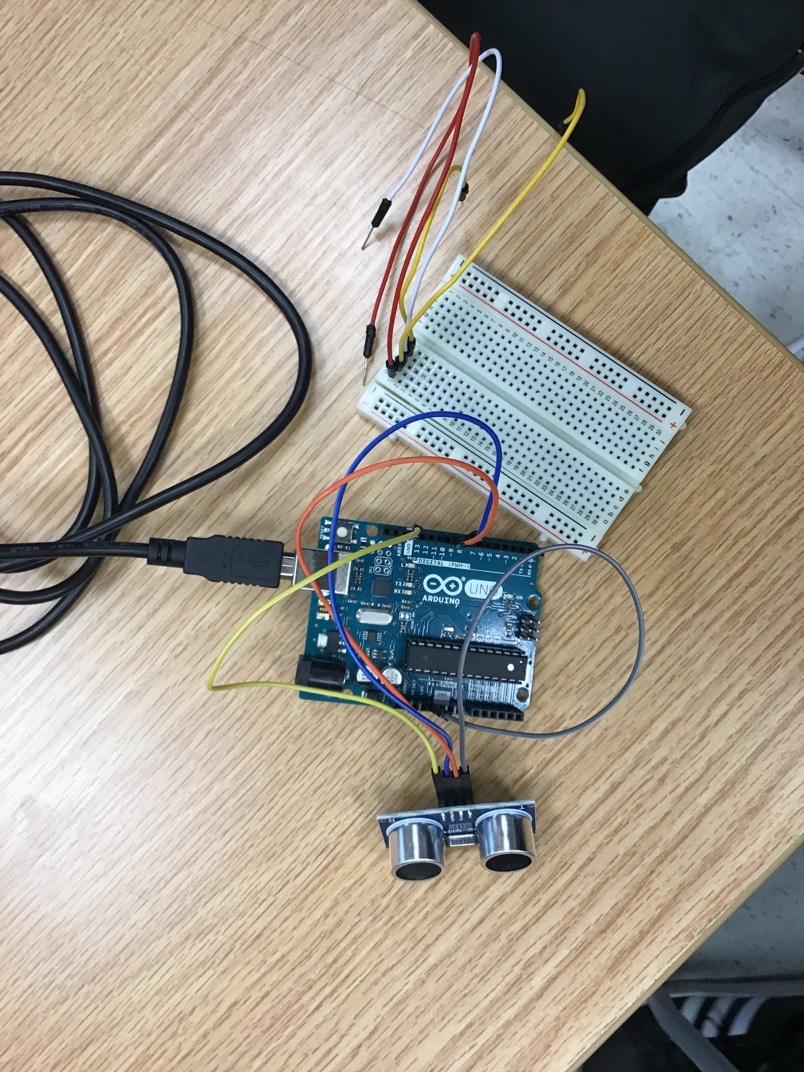

NEXT MEETING

* Decide when to meet on a weekly basis
* Discuss team name and demo day dates
* Keep working on prototype
* Bring adaptor to extended hours to test the Arduino setup

## 

## **22 January 2022 / Meeting Duration:**

ATTENDEES

All

AGENDA

* Meet with omar and tell him about our idea
* Choose demo day date
* Work on prototype
* Choose team name
  + Overhead
  + No cap
  + ultron
  + Jarvis

Work Done

* Meeting with Omar: confirming our idea with him and gathering his thoughts to make the model to his liking

(Things to mention to Omar):

* Pitch: instead of attaching a sensor and other elements to a cane, we instead thought of making a baseball cap with an ultrasonic sensor attached to it
  + How it works: The cap will start detecting anything within 11 feet, when it gets to within 5 feet, it starts to vibrate more noticeably. The sensors will be on the sides above your ears and behind your temples. The arduino and breadboard will be at the back of the hat.
* We decided to change it because the idea we had with the cane already exists, so we had to change our idea.
* Ask him what he thinks about the idea and if he has any changes to make (thoughts/opinions)
* So far, we are creating the real model by implementing electrical components such as ultrasonic sensors and the arduino.
* Completed parts of the circuitry for the prototype
* Work on physical and digital prototype
* Roles for today: Coding, Physical, Pitch

Physical Prototype: Grace, Sireesha

Coding: Rehaan, Arham

Pitch Slides: Pranathi, Nohami, Ashar, Aadi

Notes:

* Okay with the vibrations above his ears
* Likes the idea (wears hats a lot)
* Used to wear hats because of light sensitivity (when he had low vision)
* Wears hats now to protect head from over head objects
* Wears any type of hat (baseball caps work)
* We probably need to come up with a physical prototype for more feedback

Code: [Main Code](https://www.tinkercad.com/things/kFFPvGqboMV-project-invent-code/editel?sharecode=uFH4Uevkb9FiFZIe2TzD-TnqmBrKulbCIHWTEzq06uQ)

[Multiple Sensors (Fixing Code)](https://www.tinkercad.com/things/f9dNc1zj9ch-multiple-sensors-test/editel?sharecode=w-gv6Ze8yJZ02fGsDdL8QhC1GlG2BlnWvprQ5lXQUMc)

Next Meeting

* Continue working on prototype
  + Decide a day to meet up to work on it
* Work on demo day slides
* Possibly plan out video

<https://slidesgo.com/theme/business-continuity-frameworks-meeting#search-PowerPoint+Exclusive&position-4&results-10>

## 

## 

## **27 January 2022 / Meeting Duration: 90 min**

ATTENDEES

All

AGENDA

* Ask how to regulate the motor speed by going to the tech support meeting
* Continue working on the code
* Work on pitch slides
* Plan out video

# Work Accomplished

* Finished all the slides we could do with the information we have
  + Couldn’t do slides about solution because we’re still working on it
* Went to tech support meeting
* Without being able to select a port on the arduino editor, we cannot continue working on the code or hardware

# NEXT WEEK’S AGENDA

* Continue coding and prototyping hardware

## **03 February 2022 / Meeting Duration: 90 min**

ATTENDEES

All

AGENDA

* Physical Prototype Ideas - What do we send to Omar for testing?
  + Vibrations of prototype
    - Press button to create vibrations that he can feel in his hand
    - Omar tells us whether those vibrations are tolerable if placed on his head
* How might we create an on/off switch?

# Work Accomplished

* Finished all the slides we could do with the information we have
  + Couldn’t do slides about solution because we’re still working on it
* Went to tech support meeting
* Without being able to select a port on the arduino editor, we cannot continue working on the code or hardware

# NEXT WEEK’S AGENDA

* Continue coding and prototyping hardware

## **3 February 2022 / Meeting Duration: 90 min**

ATTENDEES

All

AGENDA

* Work on prototype
* Find out what aspect of our device is most important
  + So we can send the most important part of our device to Omar (if not fully completed)
* Work on Demo Day Slides

# Work Accomplished

* Finished wiring
* Worked on Demo Day Slides
* Main Code (Basic); <https://www.tinkercad.com/things/kFFPvGqboMV-project-invent-code/editel?sharecode=uFH4Uevkb9FiFZIe2TzD-TnqmBrKulbCIHWTEzq06uQ>
* PWM:

[https://www.tinkercad.com/hings/2Kc14SzBVVR-project-invent-code-/editel?sharecode=7Th4F7dKfnf4HxeJlI1HQvPOv-4HwmKcpjwwhaR_lgk](https://www.tinkercad.com/things/2Kc14SzBVVR-project-invent-code-/editel?sharecode=7Th4F7dKfnf4HxeJlI1HQvPOv-4HwmKcpjwwhaR_lgk)

* Video
  + <https://drive.google.com/file/d/1bwWzWGFhE7pr23rnHHHtpssfzuRnQMpU/view?usp=drivesdk>

# NEXT WEEK’S AGENDA

* Mount everything onto a hat
* Work on Demo Day Slides

## 

## 

## **10 February 2022 / Meeting Duration: 90 min**

ATTENDEES

All

AGENDA

* Finalize prototype to send to Omar
* Work on demo day slides

# Work Accomplished

* Half of the slides are done
  + Community Partner
  + Problem
  + Competitor Matrix
  + Next Steps
  + Refine Product Features and Solution Slides
* Ideas for how to make the circuitry smaller
  + Use smaller breadboards instead of the big ones
  + Solder the wires and use a circuit board
* Ideas for how to mount the circuitry on the cap
  + Vibration motors are on the inside of the cap
  + Sew the wires inside the seams of the cap
  + Make a pouch for the Arduino
    - Or put it on the back of the cap
    - On the outside of the cap

# NEXT WEEK’S AGENDA

* Continue to mount everything onto a hat
  + Put everything on a circuit board
* Work on Demo Day Slides

## **12 February 2022 / Meeting Duration: 240 min**

ATTENDEES

All

AGENDA

* Finalize prototype to send to Omar
* Work on demo day slides
* Set up meeting time with “coach”

# Work Accomplished

* Meeting time and Coach:
  + First meeting time: Tuesday (02/15) at 4:30, Coach: Andrei
* We changed the code to have it work with mini breadboards or a circuit board instead of a big breadboard.
  + This will help with the design of the hat, so it will be easier to arrange all the components to be comfortable and packaged in the cap.
  + New Code Link: [https://www.tinakercad.com/things/7XySFw0WNkQ-mini-circuits/editel?sharecode=wiwfIlTrDEqHX8gIX0RwKWRhNMVgsWuYEFOR8HsdkFU](https://www.tinkercad.com/things/7XySFw0WNkQ-mini-circuits/editel?sharecode=wiwfIlTrDEqHX8gIX0RwKWRhNMVgsWuYEFOR8HsdkFU)
* Plan for hat
  + Solder wires and use two circuit boards; Sew the wires in the seams of the cap
  + Have the circuit boards on the inside of the bill of the hat, while the two ultrasonic sensors will be on the top/outside of the bill of the hat

# NEXT WEEK’S AGENDA

* Prepare for pitch coaching & test hat to make sure motors & sensors work

**15 February 2022 / Meeting Duration: 90 min (EH) + 30 min (pitch coaching)**

ATTENDEES

* Sireesha and Aadi absent from EH
* Sireesha and Ashar absent from pitch coaching

AGENDA

* Finalize prototype to send to Omar
* Work on demo day slides
* Discuss roles for presentation (Pitch mentoring)

# Work Accomplished

* Finished Slides for presentation later on today (pitch mentoring)
* Grace finished the soldering before the meeting

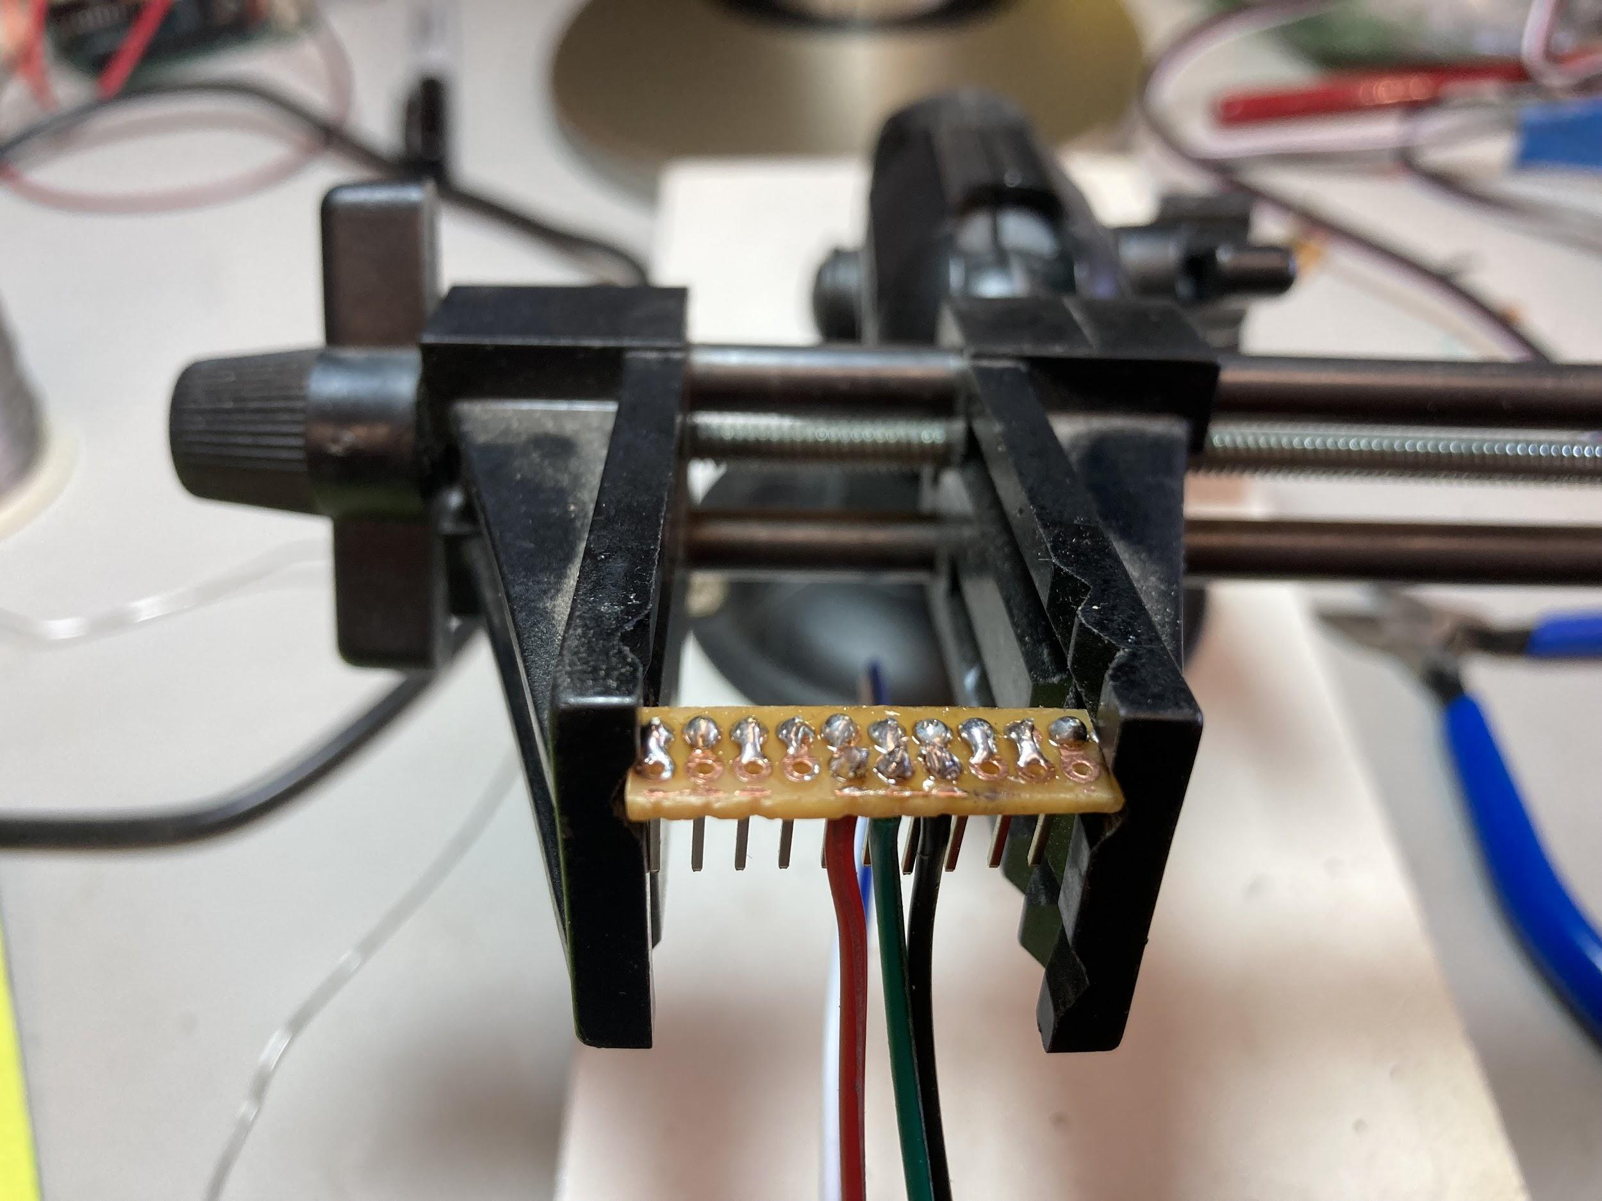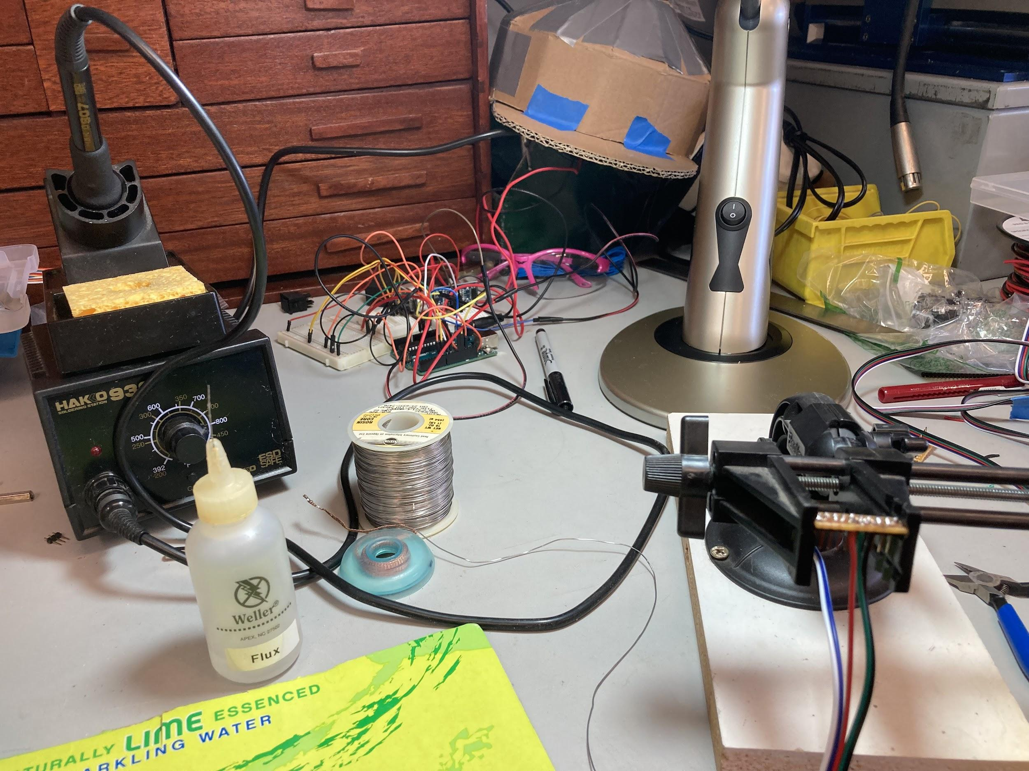

* Tested vibration motors and sensors with the hat
  + Left vibration motor and ultrasonic sensor do not currently work
    - Maybe a problem with the wiring
  + Right vibration motor and ultrasonic sensor do work
  + Motors now vibrate when objects are 3 feet away from user
  + Tested outside and made sure motors were not vibrating all the time, in a way that would be disruptive to the user
  + Was able to detect a ruler that was in front of the sensors, motors did vibrate
  + [Video of using product]

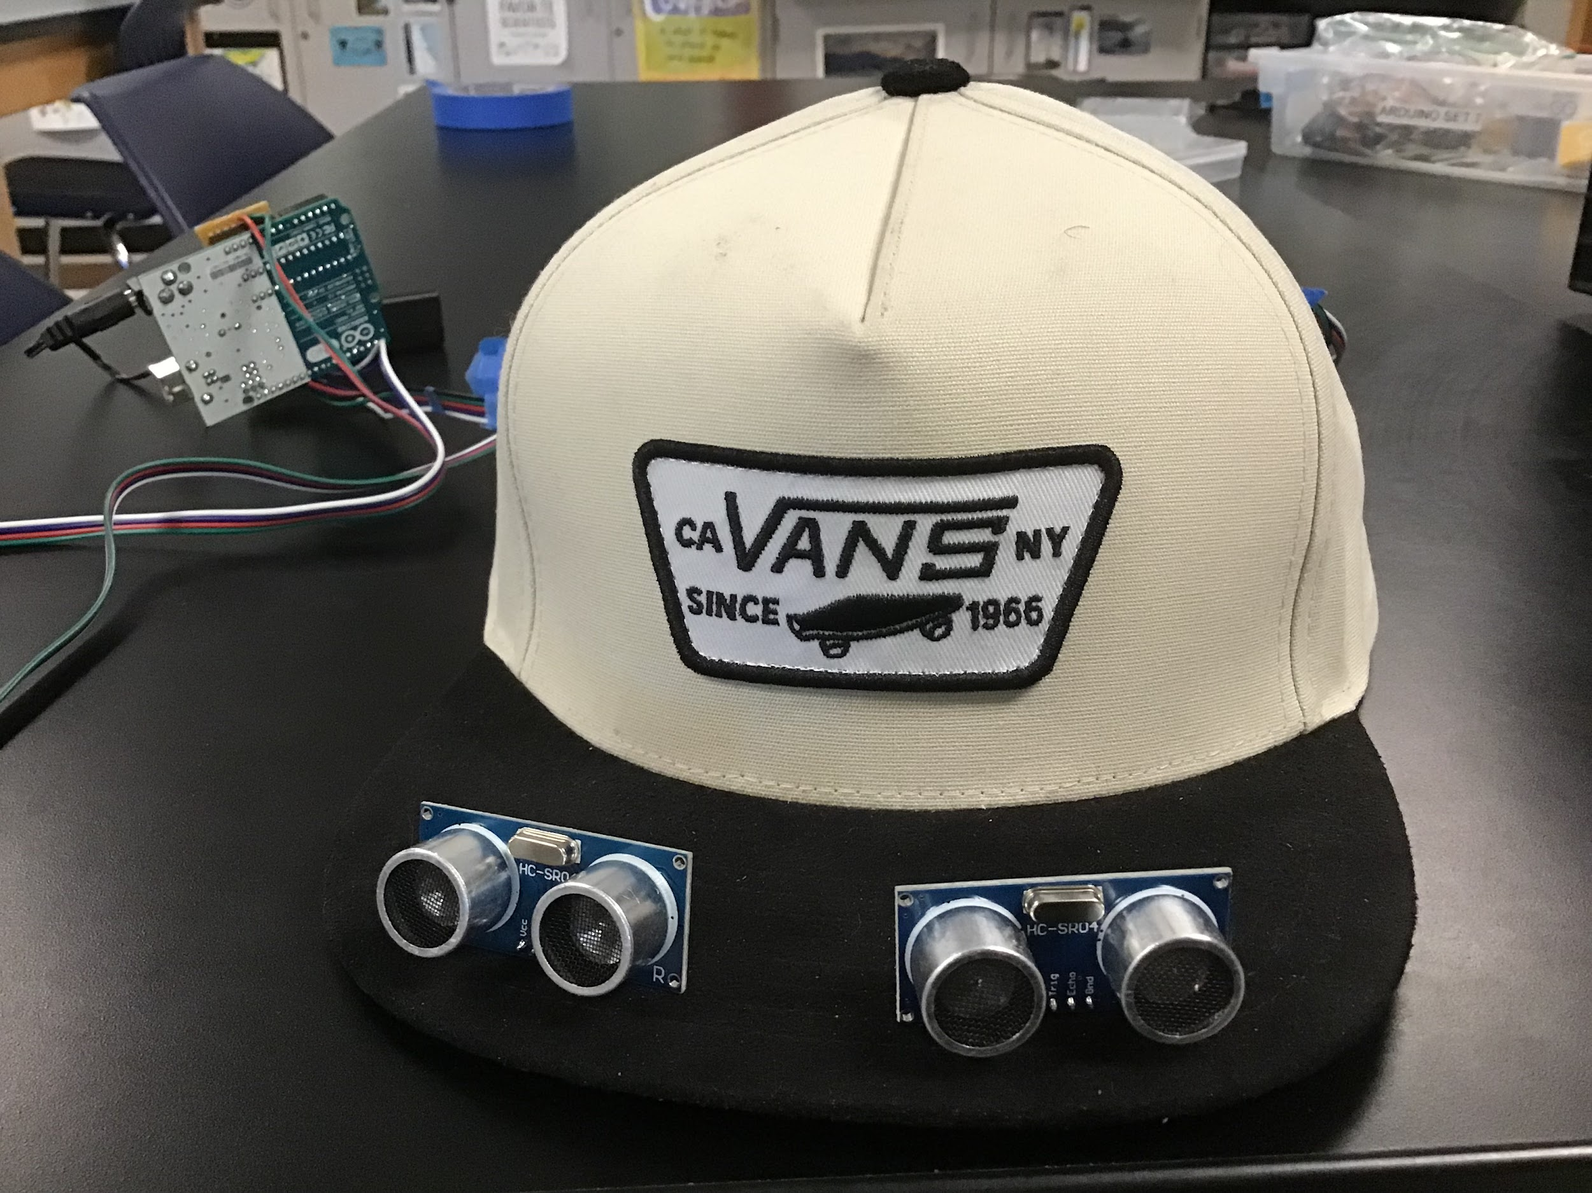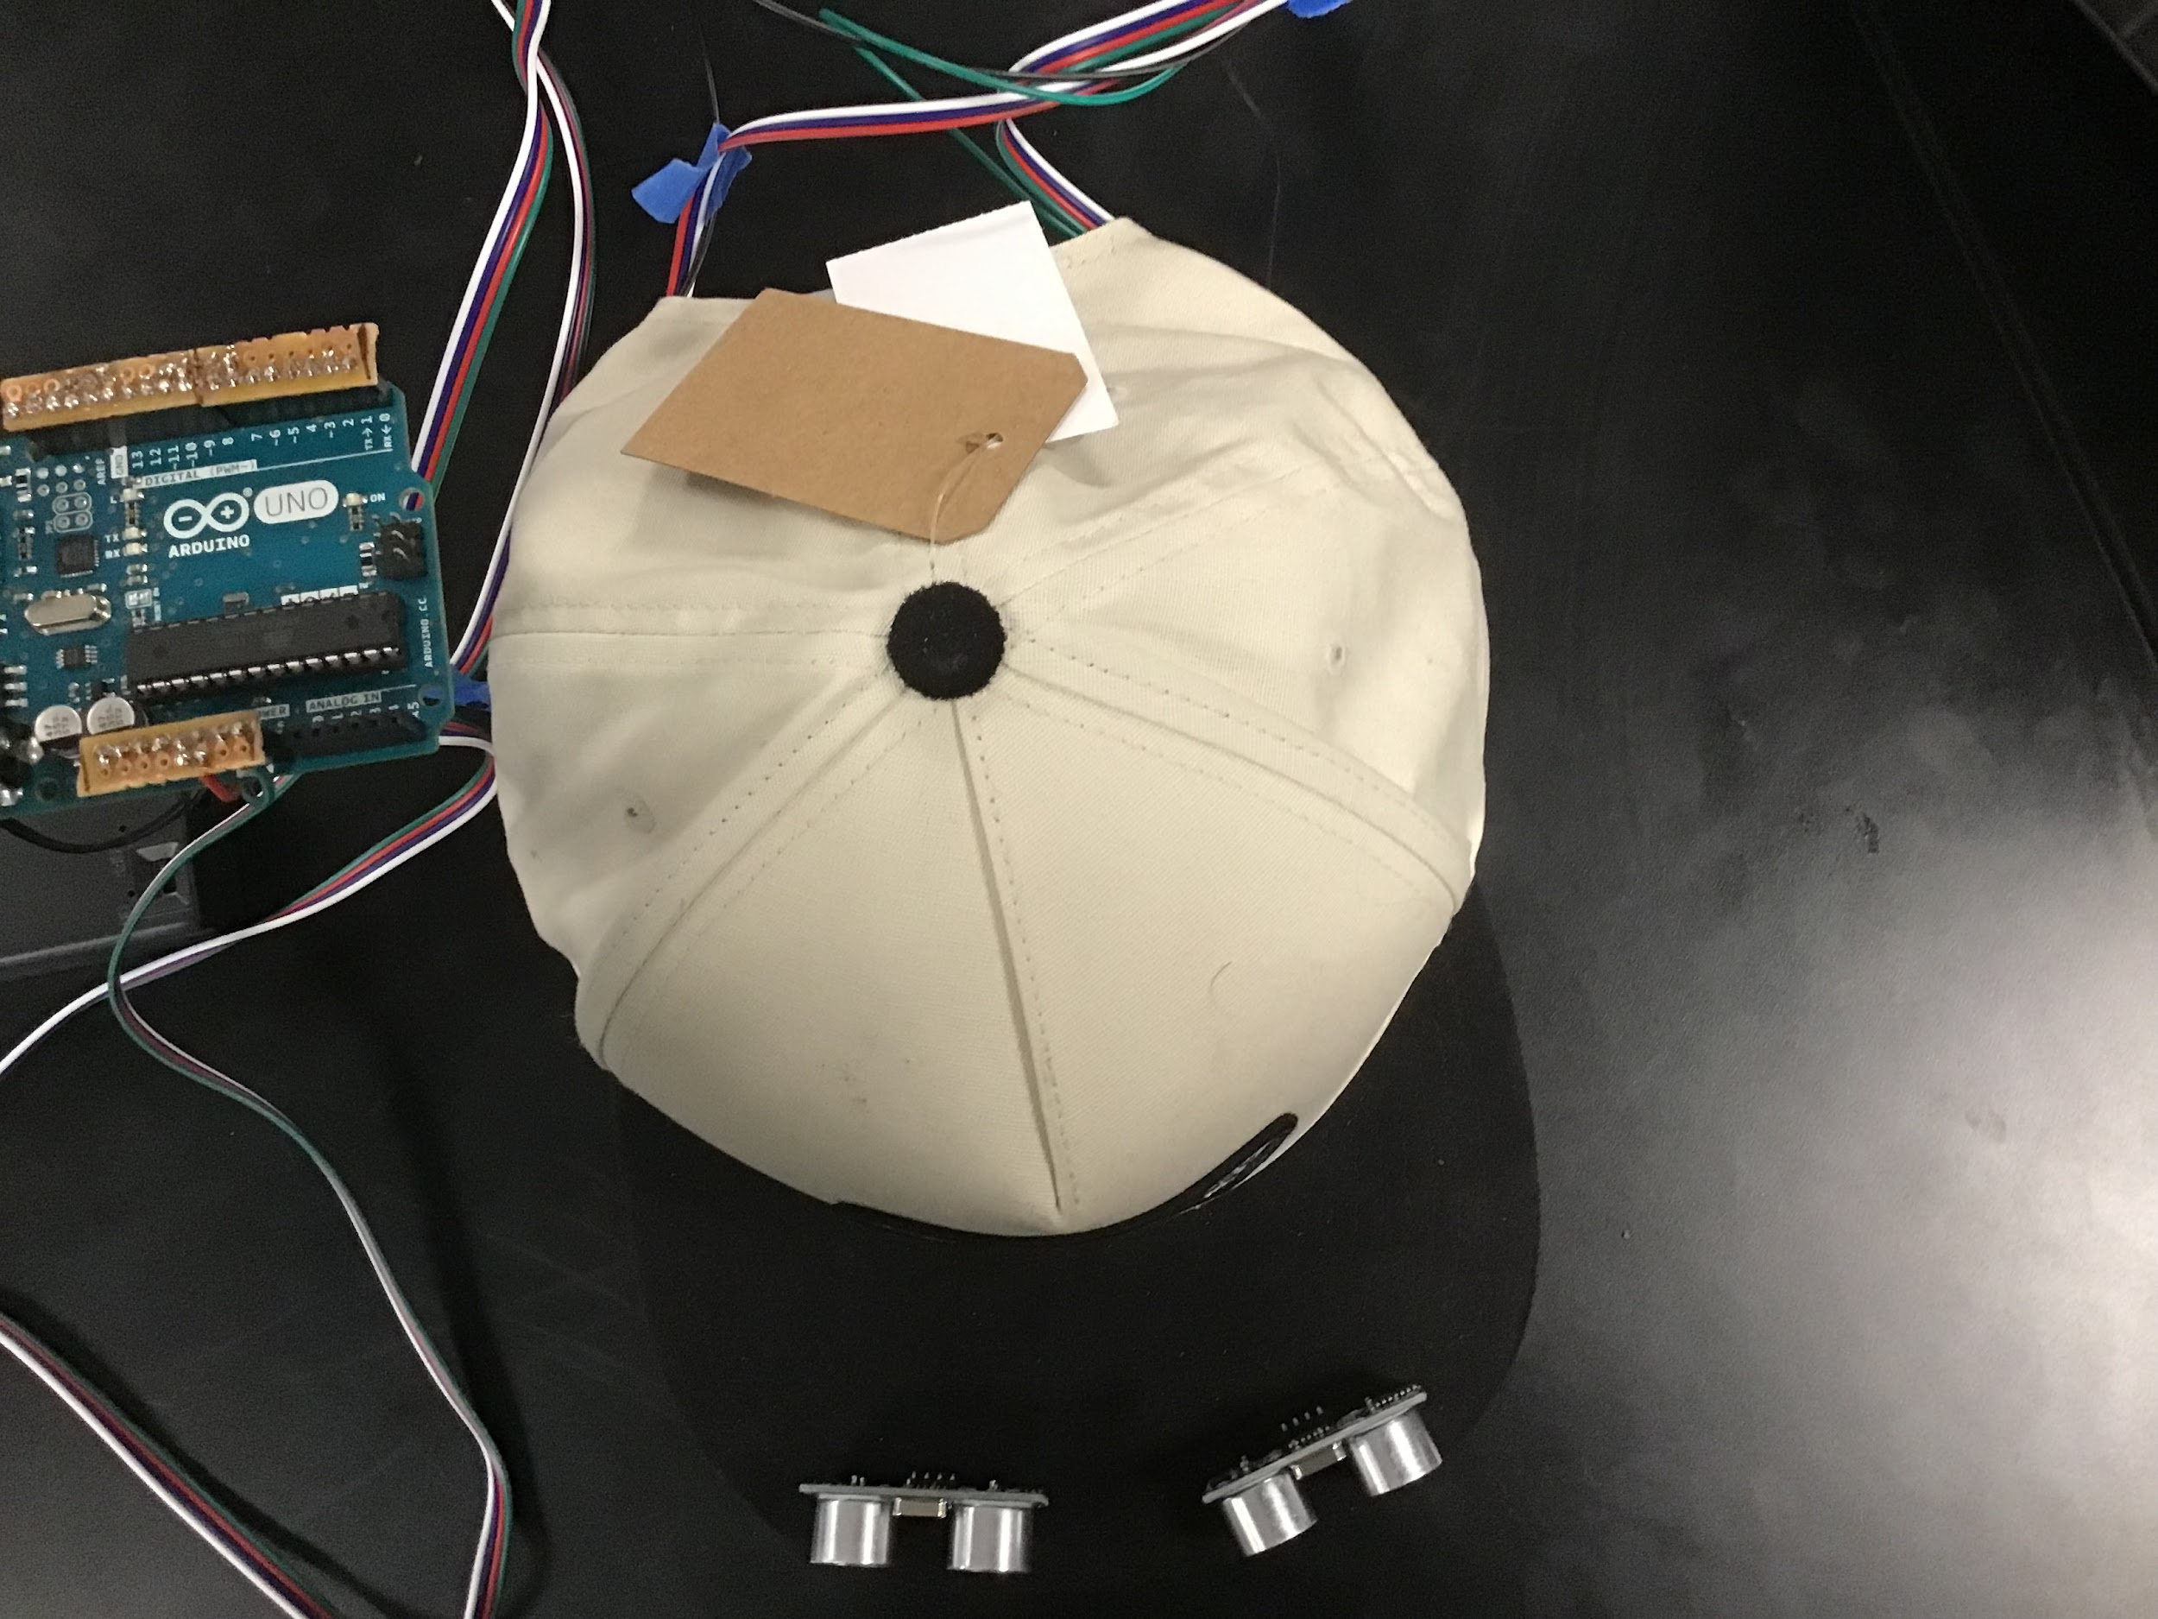

Pitch Coaching Notes:

* The slides about Omar (and quotes) were well done
  + A little more context about Omar - who he is, emotional struggles he faces
    - Try to appeal to the target audience
    - Add how Omar would be with and without this product
    - **Move quote about how Omar thinks the product would work well to a later point after there is more context about what the product actually is and does**
* May want to reach ahead towards the actual target audience, less about a potential investor and more about who exactly it is for.
  + People bulk buy the product and distribute it?
  + Individual users
* Product design
  + [Enclosures](https://www.tinkercad.com/things/gVH1HQyOVHG-spectacular-jofo-duup/edit?sharecode=179Oejj8EsHMmbyPZNCgHZkzLzBsKRpfIAxbTlrPnMI) - make it waterproof - 3d printing helps for electronics
  + Package ultrasonic sensors so they look integrated into the hat (part of the design)
  + Specify what the vibration motors do (mention them more)
    - Make diagram showing where they are
      * Possibly Side View
      * Drawings, sketches, tinkercad models, etc.
      * Make a video of a demo of the product
      * 10-20 seconds per visual (max) in a video

What kinds of questions should we ask Omar in order to get specific feedback during user testing?

* Types of things he might run into or have issues with
  + does he hit things or does he just get close
  + is this something he really wants to use
  + outside vs inside
  + pain points, things he doesn't like
  + mention specific scenarios to solve to narrow down use cases and make it more targeted
  + what is he struggling to sense/what does he run into
    - will help with quotes and presentation about running into something specific
* Once we have feedback from Omar
  + Revise slides
  + Finish prototype
    - Fix the issue with the vibration motor/ultrasonic sensor on the left
    - Add enclosures
      * 3D print?
    - Make ultrasonic sensor/wires seamless with the hat
      * abstraction/encapsulation
      * waterproof?
    - do something with the wires and Arduino after putting it in an enclosure
      * arm strap?
      * wrist band?
      * arm sleeve?

# NEXT WEEK’S AGENDA

* Review feedback from Pitch Coach
* Potentially send community partner our prototype
  + Ms. McClennan is willing to drive to Omar
* Prepare prototype to send to community partner (make a video/send an email to explain how to use it)
* Finish Pitch Slides

## 

## **3 March 2022 / Meeting Duration: 90 min**

ATTENDEES

All

AGENDA

* Work on prototype
* Demo video
* Edit slides and add the demo video when ready
* Meet with Andrei on Tuesday @ 8:00 am

# Work Accomplished

* Added to the slides
* Worked on prototype and future logistics

# NEXT WEEK’S AGENDA

* **REMEMBER:** 
  + **EXTENDED HOURS ON TUESDAY**
  + **REHEARSAL ON MARCH 17 4-4:30**
  + **VIDEOS ARE DUE ON FRIDAY 3/18**

## 

## **8 March 2022 / Meeting Duration: 90 min**

ATTENDEES

Grace absent

AGENDA

* Update slides
* Pitch Coaching

# Work Accomplished

Pitch Coaching Notes:

* More technical diagram
  + A picture of the hat on an actual person’s head would be more useful
  + Show how the prototype actually works within the picture - ultrasonic sensors sensing objects, vibration motors alerting users
  + If it feels too bare, add a couple bullet points
  + Add functional details - detects objects from a 1 meter range, etc.
  + Add a “how it works” diagram
    - Maybe a how-to-use it tutorial
  + Add any problems we encountered regarding our design procedure
  + Less is better
  + Fix some of the shapes (ex. Slide 10 and 14 - looks like tombstones)

# NEXT WEEK’S AGENDA

* **REMEMBER:** 
  + **REHEARSAL ON MARCH 17 4-4:30**
  + **VIDEOS ARE DUE ON FRIDAY 3/18**

## 

## **12 March 2022 / Meeting Duration: 4 hr & 30 min**

ATTENDEES

All

AGENDA

* Update slides
* Record pitch
* Finish video
* Take team picture

# Work Accomplished

* Updated and edited slides
* Recorded and turned in rough draft pitch
* Finished prototype video
* Took team picture

# NEXT WEEK’S AGENDA

* Continue to work on final draft of slides
* Practice pitch for demo day: **March 17 4-5 pm**
* Work on the prototype to fix motor

**17 March 2022 / Meeting Duration: 40 minutes**

## ATTENDEES

All

AGENDA

* Demo Day X Rehearsal
* Fix final Demo Day video

# Work Accomplished

* Updated and edited slides
* Recorded and turned in rough draft pitch
* Finished prototype video
* Took team picture

# NEXT WEEK’S AGENDA

* Continue to work on the final draft of slides
* Practice pitch for demo day: **March 17, 4-5 pm**
* Work on the prototype to fix the moto

## 

## **24 March 2022 / Meeting Duration: 90 minutes**

## ATTENDEES

All

AGENDA

* Demo Day X Rehearsal

# Work Accomplished

* Updated and edited slides
* Recorded and turned in rough draft pitch
* Finished prototype video
* Took team picture

# NEXT WEEK’S AGENDA

* Continue to work on the final draft of slides
* Practice pitch for demo day: **March 17, 4-5 pm**
* Work on the prototype to fix the moto

## 

## **26 March 2022 / Meeting Duration: 1 hr 30 minutes**

## ATTENDEES

All

AGENDA

* Demo Day X Practice
* Answer Feedback Questions from our peers

# Reflection Questions/Answers

1. During our design process, we encountered numerous challenges. One of them was determining the materials we would use for our device. There were many materials that could help us, but we needed to ensure that they were all compatible with one another. Even after we selected our materials, we ran into another issue: getting the code to work properly with the designated circuitry. This had been a month-long challenge.
2. What has kept us going is knowing that we have the ability to help Omar. The thought that our device would be able to help him in his everyday life was able to give us motivation when we encountered any obstacles.

Longer Version

1. During our design process, we encountered numerous challenges. Though these challenges were tough to overcome, they taught us a lot about how to persevere and become better problem solvers in the process. One of the challenges was determining the materials we would use for our device both in the stages of prototyping and as we begin to make our device more compact. There were many materials that could be implemented into the device, but we needed to ensure that they were all compatible with one another and worked flawlessly as a unit. Even after we selected our materials, we ran into another issue: getting the code to work properly with the designated circuitry. Every component is built to work with different compatible parts, and so to find the materials we needed that would work with both the code and the device was a struggle we had to face. This had been a month-long challenge. As we approach the revision phase where we begin to compact and change components, this will continue to be a challenge we have to address and overcome.

2. Having the ability to help Omar has been that thing that has really encouraged us to persevere and face the challenges of creating this project. Hearing his excitement about our project and the potential that it has to make him and other lives easier are really inspiring. It’s been a long process, but the thought that our device would be able to help him in his everyday life was able to give us motivation when we encountered any obstacles. It’s an amazing feeling knowing that the device that you’re creating is something that could change so many lives and affect so many people, so we hope that by using this motivation, we can bring this kind of product to market and bring helpful change to the affected communities.

Work Accomplished

* Common Questions/Topics:
* How fast is Omar able to react from objects in his way? Is it enough time?
* Would crowded areas present a problem as the vibration sensors will buzz constantly?
* Do the vibrations hurt or give the user a headache?
* What if an object is flying or comes from behind?
* Is the device portable/why is it specifically a hat?
* Is it heavy?
* What are your future plans?

# NEXT WEEK’S AGENDA

* **Demo Day!**

## **7 April 2022 / Meeting Duration: 90 minutes**

## ATTENDEES

All

AGENDA

* Thank you gift for Omar!

# Work Accomplished

* Hello Omar, you’ve done so much for our team that we’re thankful for
* Being an awesome community partner
* Taking time out of your day to do interviews with us
* Getting back to our emails quickly
* Being flexible
* User testing our prototype
* Writing encouraging comments on demo day
* Giving us helpful feedback… which helped us win an award!

Thank you so much for all of the help throughout this process, and we can’t wait to continue working with you to hopefully bring this product to market!

NEXT WEEK’S AGENDA

* Receive donuts and celebratory breakfast
* Donate the $500 to a trusted foundation: My wallet
* Join Craig’s zoom calls to write really encouraging and enthusiastic messages in the chat that support other people in the call
* <https://drive.google.com/file/d/1qqUUajDtb9ofmMLHYP3-UXqU8VS7F5Z0/view>